
Федерация экстремального спорта


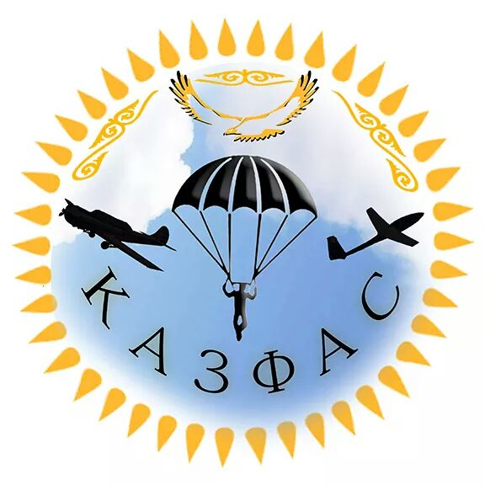

Local Regulations
Summer Championship of Kazakhstan
8th August – 14th August 2025 , Taldykorgan, Kazakhstan

Organised by:
Kazakhstan Air Sports Federation
Federation of Extreme Sports
ALGA sport club

These local regulations are to be used in conjunction with the most recent versions of:

• General Section of the FAI Sporting Code
• Section 7 Common of the FAI Sporting Code.

1. Contacts & Officials

Organizing NAC: Kazakhstan Air Sports Federation
Address: Dostyk 114 Office 127
050051 Almaty, Kazakhstan
E-mail: gvexler@list.ru
Tel: +7(727)2628802

Local organizers: ALGA sport club
Konaev street 16
040000 Taldykorgan, Kazakhstan
E-mail: Virshkidavid@gmail.com
Tel: +7(771)5542876

• Event director David Virshki
- Meet Director Alexey Tarasov
• Safety Director Yuriy Medvedev
• Rescue Coordinator Department of Emergency Situations
• Scorer, IT Pavel Vinchuk
• HQ/Admin Usmanov Yahar
• Launch Marshall Rinat Mazhitov

2. Program

Event program
Official Registration: Fri,8th August
Opening ceremony: Fri,8th August
Contest flying days: Fri,8th August to Thu,14th August
Prize-giving and Closing ceremony: Thu,14th August
The event program is subject to change. Any changes to the schedule will be announced by the Meet Director at the Team Leader Briefing or Pilot Briefing and posted on the notice board.

The competition will have FAI CAT-2 status, and Pre PWC status

Typical daily schedule

10:30 Transportation to Take off
11:00 Team leader/Pilot briefing/ Start of competition day
18:00 End of competition day

The daily schedule is subject to change. Any changes to the schedule will be announced by the Meet Director at the Team Leader Briefing or Pilot Briefing and posted on the noticeboard.

3. Entry

Numbers
- The maximum number of pilots in the competition is 150.

4. Entry fee

The Entry fee will be:

FOR FOREIGN PILOTS .
The standard entry fee is 150 euro.
Payment by cash at HQ
FOR KAZAKHSTAN PILOTS

Standard entry fee- 150 euro

Payment by cash at HQ.

Team leaders who are also pilots in the competition will pay only the pilot entry fee.

The Entry Fee includes:

- Transport to take-off and retrieve
- Emergency rescue and first aid medical service
- Live tracking
- Medals and diplomas
- T-shirt
- Daily launch packs

5.Payment
The Entry Fee will be paid in cash upon arrival of the athletes at the registration.

6. Registration

The official registration will be on Friday, 8th August, at HQ.
Entry forms will be completed during the registration.

List of documents to provide at the registration:
- Proof of his/her Identity and Nationality
- FAI Sporting License
- National Pilot's license
- Signed application form
- Satisfactory evidence of glider/equipment airworthiness
- Insurance (for foreign participants)

.
7. Insurance

The organizers require that a documentary proof in English be submitted to the registration team before the start of the competition:
- Valid insurance covering the risk of liability in the amount of at least 20,000 euros.
- Valid personal accident insurance for paragliding competitions. This should include repatriation to the country of origin and medical treatment, if necessary.
Important note: The Organizer will not provide insurance for the participants of the competition.

8. Equipment

General
All equipment must comply with S7 .The equipment will checked at the registration by Safety Director.

Radios
The organisation may require pilots to carry a radio able to receive and transmit on the safety frequency. The radio frequency is 146,675 MHz.Voice activated microphones (VOX operated) are strictly forbidden.

9. Safety committee
The Safety Committee will include: Meet Director, and a minimum of two experienced pilots (one local, two visitor – they must be competitors).
10. Competition site

Ekpendi, Zhetysu region, Kazakhstan
Altitude: 1800 m asl (N44° 50' 38,3", E78° 39' 14,6")

Take off altitude 1800 m asl
Landing altitude 1000 m asl
Height Difference 800 m
Distance from take-off to landing 1,5 km
Wind direction Take off wind W or NE
Landing wind NE or W.
.

11. Take-off area

During the competition, the take-off area will be reserved for the pilots, the media and identified staff personal.

12. Launch

Method: Hill Launch
Other: According to Section 7 3.2. and 3.3.

13. Class rankings

At our competition we will have podiums for: Overall, Juniors, Women Overall, Fun class, Sport class and Serial class.

14. Rest day

No rest day planned.

15. Wind speed

According to Section 7.
The maximum permitted wind speed, will be 9 meters per second.

16. Task Information

A task board at the take off will show:

• the task,
• the meteorological information,
• information related to competition and/or social events.

17. Complaints and Protests
Complaints and Protests will be dealt with according to the procedures in Section 7 and General Section. It should be made with the minimum delay and it will be dealt with expeditiously.
If the complainant is not satisfied with the outcome, the team leader may make a protest in writing to the Meet Director or his deputy. The time limit for protests is 2 hours (1 hour after last round) after notification of the result of the complaint. The protest fee is € 50. It will be returned if the protest is upheld.
The Official Protest forms and printed copies of S7 will be available at the Recorder table.

18. Emergency procedures

An ambulance will be provided during the competition. The nearest hospital is a 20-minute drive away in Tekeli.

19. Participation of Non-FAI Member Pilots

Pilots from countries that are not members of the FAI may participate in the competition under the following conditions:
- Eligibility: Pilots must hold a valid pilot's license recognized by their national aviation authority or equivalent governing body.
- Documentation: Non-FAI member pilots must provide the following documents at registration:
- Proof of Identity and Nationality
- National Pilot's License or equivalent
- Signed application form
- Satisfactory evidence of glider/equipment airworthiness
- Insurance: Non-FAI member pilots are required to submit documentary proof of valid insurance covering:
  - Liability, with a minimum coverage of €20,000.
  - Personal accident insurance for paragliding competitions, including repatriation to the country of origin and medical treatment, if necessary.
- Compliance: Non-FAI member pilots must adhere to all competition rules, regulations, and safety procedures outlined in this document and any additional instructions provided by the organizing committee.
- Entry Fee: Non-FAI member pilots will be subject to the same entry fees as foreign pilots, as outlined in section 4.
- Acknowledgment: Participation in the competition by non-FAI member pilots implies their acknowledgment and acceptance of all rules and regulations governing the event.
- Disqualification: Failure to comply with any of the above conditions may result in the disqualification of the pilot from the competition.

This section ensures that pilots from non-FAI member countries can participate in the competition while maintaining the necessary safety and regulatory standards.

