2022 Green Swamp Sport Klassic Risk Management Plan

The purpose of this Risk Management Plan is to minimize the risks of injury to pilots, staff, and spectators, and of property damage, as they relate to the hang gliding activities associated with the USHPA and Green Swamp Sport Klassic (GSSK) occurring in April of 2022 at the Wilotree Park, 1.5 miles south of Groveland, Florida.

This plan identifies the actions required to mitigate the risks identified in the Wilotree Park/Sheets Airfield risk assessments worksheet using the USHPA Hang Glider Site Risk Assessment Worksheet.

1. Site Overview
Wilotree Park, Sheets Airfield of State Highway 50 and State Highway 33 in Groveland, Florida. It has two 2,000-foot long grass runways: a north/south runway that includes an additional 1,000-foot north extension, and an east/west runway. This airfield has been used for aerotowing hang gliders for approximately 20 years.

The property includes additional grass fields adjacent to the grass runways. There is a large pond on the east side and there are treed areas on all sides.

There are five hangars and three hang glider storage containers east of the north/south runway. Picnic tables are located east of the north/south runway and west of the club house. In addition to the clubhouse there is an swimming pool to its south.

There is trailer and RV parking west of the clubhouse and North of the pool. There is additional camping and trailer parking by the lake to the east, and in the woods to the west of the north/south runway. There can also be trailer parking in the southeast corner.

Sheets Airfield coordinates for the competition are 28°32.137', -081°50.760'

The maps of the launch areas and the anticipated goals are included in Sections 7 and 8.

2. Personnel
Meet Organizers- Wolfpack Hang Gliding, LLC owner Ric Caylor.
Meet Director – Wolfpack Hang Gliding, LLC owner Ric Caylor.

Assistant Meet Director – Larry Bunner
Tow Plane Director – Jim Prahl
Safety Director – Eric Williams
Safety Committee – TBD by competitors
Mentor Director – Pete Lehmann, a long time experienced competition pilot, cross country with several record breaking flights and previous US hang gliding team captain. He has also be a GSSK mentor for many years.
Volunteer Director – Belinda Boulter, an experienced meet director. Previous experience over the past years managing and directing many US hang gliding competitions.
Launch Director – Heather Renihan, an experienced Launch director. Previous experience launching pilots at 2021 Wilotree and Paradise National events, as well as the 2021 Santa Cruz Flats Race.
Weather Forecasting Leader – Davis Straub, an experienced competition pilot with many years of experience of local weather conditions. Previous experience in this role at three Big Spring meets, multiple Quest Air meets and GSSK events.
Task Committee Leader – Tim Delaney, an experienced competition pilot with many years of experience of task coordination. Previous experience in this role at multiple Wilotree National meets, El Penon Race meets and GSSK events.
Task Committee – TBD by competitors
Scorekeeper – Attila Plasch with Kate Griffin as his assistant. Kate officially has scored several past meets.

Launch Line Assistants - TBD
Protest Committee – TBD by competitors
Staff Volunteers – Additional on-site staff
Pilots – Up to 40 pilots, will be flying in the events.

3. Position Descriptions

A. Meet Organizers
Responsible for ensuring that the competition is safe and successful, and meets all requirements set forth in the USHPA Manual , USHPA Race To Goal Competition Rulebook and the FAI Sporting Code Sections 7 and 7A for hang gliding, as well as the local rules (see below). They are responsible for all organizational matters before, during, and after the event including but not limited to the following:
- Complete and submit USHPA ACE applications.
- Gather all the information listed in the Event Insurance Preparation List.
- Complete the Wilotree Park Site Risk Assessment Worksheet with all the appropriate signatures.
- Develop the Risk Management Plan for Wilotree Park.
- Complete Tow Device Supplemental applications.
- Complete USHPA Event Insurance application and work with the USHPA and the RRRG to get it approved.
- Communicate the Risk Management Plan to all participants prior to the event.
- Provide information about emergency facilities nearest to launch. The information can be included in the registration package or posted at the meet. When the information is posted, competitors and drivers must be notified of where to find the emergency information at the pilot briefings.
- Develop and communicate the Emergency Response Plan (Appendix A) to all participants.
  - Ensure Incident Information Collection Form (Appendix B) and CIVL Incident Report Form are used as part of the response. These forms are printed and used to collect the incident reports in the field for later use in filling out the on-line reports.
  - Submit accident reports to USHPA using the USHPA incident report page: https://www.ushpa.org/page/incident and here:
https://www.ushpa.org/page/incident-report and as an additional option here: the Accident Incident Reporting System (http://airs.ushpa.aero) and to CIVL (on-line here: http://civlrankings.fai.org/FL.aspx?a=357&person_id=6143&) immediately after the competition.Report all accidents and incidents using the Potential Claim Notification form (available on the AIRS “Thank You” page) within 7 days after the conclusion of the competition.
- Communicate to responsible parties of increased air traffic during the event.
- Validate on-line pilot USHPA membership, and that pilot proficiency ratings meet the minimum requirements for the event.
- Provide thirty-day USHPA membership forms to be filled out and paid for by foreign pilots. Check foreign pilot proficiency ratings on-site using the International Pilot Proficiency Identification (IPPI) card.
- Provide document access to all participants for FAR 103
(https://www.eaa.org/en/eaa/aviation-communities-and-interests/ultralights-andultralight-aircraft/getting-started-in-ultralight-flying/about-faa-part-103-forultralights), CIVL Sporting Code, USHPA Competition Rule Book, and Sanction Manual (https://www.ushpa.org/page/download.aspx?DocKey=526), and the local rules.
- Provide maps of the airport delineating parking, camping, spectator viewing, set up/teardown, tow plane, staging/launch and landing areas.
- Provide maps of the task area controlled airspace.
- Procure competition staffing team.
- Make sure that all competitors, staff, volunteers and persons involved with the running of the meet sign the then-current USHPA competition/event waiver
(available at
http://www.ushpa.aero/forms/Info_USHPA_Release_Waiver_Competition.pdf) prior to assisting or participating in, any meet activities. Make sure that anyone under 18 have the signed consent of a legal guardian on the waiver.
- Have all competitors, staff, volunteers and persons involved with the running of the meet sign all additional waivers.
- Offer site briefing to all participants prior to the start of the competition.
- Provide a first aid kit.
- Provide adequate restroom facilities.
- Provide the required number of trophies and recognition.
- Procure sufficient tow planes and pilots to handle the pilot demand.
- Submit all official meet results to USHPA within 10 days and to CIVL within 30 days of the end of the competition.
- Provide awards to the top three finishers in the Sport class. Identify the top 10 overall.
- Notify the pilots that they will be requested to complete an on-line survey from USHPA to improve future competitions.
- Provide list of participants, their USHPA numbers, and their email addresses to the USHPA office for the Online Survey.
- Convene with the Meet/Safety Director each day to evaluate whether the conditions (i.e. wind speed, direction, gust factor) for the upcoming day will support safe towing operations.

B. Meet Director
Works in concert with the Meet Organizers to ensure the competition is safe, successful and meets all requirements in the USHPA Sanction Manual, USHPA Race To Goal Competition Rulebook, the FAI Sporting Code Sections 7 and 7A, and the local rules. He is responsible for the overall safe conduct of the competition including but not limited to the following:
- Work closely with Meet Organizers prior to the competition to ensure all organizational aspects are being adequately addressed.
- Conduct the initial mandatory pilot briefing referring to the Risk Management Plan and the local rules as necessary. Parts of this briefing may be delegated.
- Conduct daily pilot briefings covering safety first, daily winners, weather conditions and tasks for the day.
- Provide oversight for the implementation of the Emergency Response Plan (Appendix A) for any significant safety event.
  - Ensure Incident Information Collection Form (Appendix B) and CIVL Incident Report Form are used as part of the response. These forms are printed and used to collect the incident reports in the field for later use in filling out the on-line reports.
  - Submit accident reports to USHPA using the USHPA incident report page: https://www.ushpa.org/page/incident and here: https://www.ushpa.org/page/incident-report and as an additional option here: the Accident Incident Reporting System (http://airs.ushpa.aero) and to CIVL (on-line here:
http://civlrankings.fai.org/FL.aspx?a=357&person_id=6143&) immediately after the competition.
  - Report all accidents and incidents using the Potential Claim Notification form (available on the AIRS “Thank You” page) within 7 days after the conclusion of the competition.
- Continually assess conditions at Wilotree Park for newly created hazards that could possibly impact the safety of the pilots, staff, spectators, public and property. Immediately implement actions to mitigate those hazards and communicate to all personnel as soon as practical.
- Closely monitor weather reports and changing conditions. When adverse conditions arise consult with the Safety Director to possibly suspend towing operations and/or stop/cancel the task. The Meet Director has the final authority for stopping or cancelling a task.
- Maintain a list of pilot radio frequencies and driver cell numbers to aid in notifying all pilots of a stopped or cancelled task.
- If a task is stopped or cancelled, broadcast it on the pilot radio frequencies and notify their drivers via cell phone.
- Provide oversight regarding safe effective towing operations and provide feedback to the Safety, Towing and Launch Directors as needed.
- Provide oversight to the Task Committee and Weather Forecaster with an emphasis on safety and provide feedback as needed.
- Provide oversight to and direct staff and pilots as necessary to ensure safe effective towing operations.
- Verify that the competition compiles with FAR’s, local and state regulations as applicable.
- Ensure that a NOTAM (Appendix C) is issued for every day of the competition, including practice days if applicable.
- Track the automated pilot landing notices to verify that all pilots have been accounted for at the end of each day.
  - At ~7:00pm, contact drivers for any pilots not accounted for to ensure they are safe.
  - Take actions up to and including implementing the Emergency Response Plan should pilots not be accounted for or that need additional aid.
- Consult with Meet Organizers to interpret unclear rules.
- Document, evaluate and make final decision on verbal protests. Written protests will be evaluated and resolved by the Protest Committee.
- Notify pilots of any protests made and their status.
- Debrief with the Tow, Safety and Launch Directors at the end of each day to identify improvements and implement actions to ensure safe towing operations.
- Convene with the Meet Organizers, Weather Forecaster and the Safety Director each day to evaluate whether the conditions (i.e. wind speed, direction, gust factor) for the upcoming day will support safe towing operations.
- Act as the final authority for penalties regarding rules violations and unsafe behaviors up to and including disqualification.

C. Safety Director
Primarily responsible for ensuring pilots, staff and spectators are managing any risks that may compromise their safety and are conducting themselves in a safe manner during the competition.
- Setup the signage for the parking and non-parking areas. Place barrier tape where needed.
- Setup the barriers or assign a monitor on Groveland Airport Road and the two track road coming in from the north.
- Communicate the warnings about the potential for accidents at the intersection of Highway 33 and Groveland Airport Road to all participants, volunteers, etc.
- Assign volunteers to keep spectators clear of the launch and landing areas. Place barrier tape as needed.
- Meet with the Task/Safety Committees to verify that the task for the day is safe for all pilots.
- Hold a Safety Briefing included in the first Pilot Briefing, using the Risk Assessment outlined in the USHPA Sanctioning Manual, and including weak links, bridles, launching and towing issues.
- Determine the launch staging and launch box placement prior to the safety briefing and communicate this to the pilots and Launch Director.
- Provide safety input at each pilot briefing, identifying any adverse conditions or behaviors and the mitigating actions that personnel need to be aware of.
- Brief the Launch Director and launch staff prior to the start of each day to review expectations regarding towing operations and pre-launch checks (Appendix D).
- Brief the Towing Director prior to the start of each day to review expectations regarding towing operations and tow plane pre-flight checks (Appendix E).
- Ensure hang glider staging and launch box location and wind indicators are setup properly to support safe towing and landing.
- Authorize the start of towing operations at the beginning of each task by meeting with the Safety Committee just prior to the launch open time to validate that the tasks and conditions are safe to start towing operations.
- In the event of a significant safety incident, implement the Emergency Response Plan (Appendix A) and coordinate first responders to the scene.
- Continually assess weather conditions, air traffic, towing operations, equipment and pilot readiness to identify unsafe conditions and take actions to mitigate including suspending tow operations.
- Consult with the Meet Director when unsafe conditions arise and provide input on stopping or cancelling the task
- Prohibit the use of any item that may create a safety hazard.
- Consult with Meet Organizers and Meet Director to interpret unclear rules regarding safety.
- Convene with one of the Meet Organizers and the Meet Director each day to evaluate whether the conditions (i.e. wind speed, direction, gust factor) for the upcoming day will support safe towing.

D. Towing Director
Responsible for ensuring that the aerotow operations are conducted in a safe and effective manner including but not limited to the following:
- Ensure tow pilots are at the initial pilot briefing on Saturday night and subsequent daily briefings. If not available, cover critical information with them prior to the start of towing operations.
- Conduct a daily briefing with the tow pilots to discuss safety issues, tow plane readiness including pre-flight checks, the day’s task and any comments or concerns that need to be addressed.
- Ensure planes are pre-flighted using the Dragonfly Checklist (Appendix E). He will oversee pre-checking all the tugs. He will "green tag tugs" for flight operations each day, and "red tag" any not ready.
- Ensure tow planes are fueled up prior to the start of each day.
- Provide feedback to the Meet Director regarding safe towing operations and actions needed to improve them.
- Provide Spectra tow ropes of approximately 150’
- Counsel tow pilots not to take pilots over 2000’ AGL unless authorized for Sport Class.

E. Launch Director
Responsible for ensuring that the hang glider towing operations are conducted in a safe and effective manner including but not limited to the following:
- Ensure all launch staff are at the initial safety briefing on Saturday night and subsequent daily briefings.
- Set up the launch staging lines and launch box and wind indicators based on the guidance from the Safety Director.
- Make sure that all hang gliding vehicles are clear of the launch area and runways 15 minutes before the launch opens.
- Continually assess conditions, equipment and pilot readiness from a safety perspective and recommend to the Safety Director to suspend tow operations if safety concerns arise.
- In the event of an emergency, suspend towing operations and perform actions as directed by the Meet Director (i.e. Ensure clear path for EMS vehicles to the scene).
- Perform pre-flight checks on all carts prior to the start of each day including wheel rotation, tire pressure, glider hold down hose/rope, saddle integrity and tail configuration. Quest Air staff will pre-check launch carts: grease the wheels, check tires for air pressure, check cradles, check keel height adjuster clips and have extra clips. Carts will be set to the right height for pilots. Carts will be kept in good condition and with proper tire pressure during the competition; an air pressure tank will be available at the cart setup area.
- Communicate expectations to the staff regarding pilot pre-flight checks referencing the Hang Glider Pilot Aerotow Checklist (Appendix E) at the start of towing operations each day.
- Provide oversight to launch staff and give feedback as necessary to ensure safe towing operations.
- Verify new weak links are available at the launch area prior to the start of towing operations each day. Appropriate pilot weak links will be made up in advance. Pilots must use weak links provided by the meet organizers and in a manner approved by the meet organizers. All weak links will be checked on launch, and use of inappropriate weak links will require the pilot to go to the end of the launch line to change the weak link.
- Weak links should be placed at one end of a shoulder bridle. The tow forces on the weak link will be roughly divided in half by this placement. Pilots will be shown how to tie the weak link so that it more likely breaks at its rating breaking strength.
- Conduct a launch staff debrief at the end of towing operations each day to identify improvements and actions needed to improve safety and provide feedback to the Meet and Safety Directors as needed.
- Wind direction and velocity determine the launch area and launch direction. South-southeast wind speeds up to 15 - 20 mph can be accommodated from the north-northwest launch area. Westerly winds up to 10 - 15 mph can be accommodated from the east and southeast launch. East winds up to 10 - 15
mph can be accommodated out of the west launch. Northerly winds 10 - 15 mph can be accommodated out of the south launch.
- Variations in wind direction and gust factors below 5 mph will be evaluated to determine launch safety. Gusting over 5 mph will keep the launch suspended or closed.
- Towing operations protocol at Wilotree Park is to check for other tow vehicles prior to launching each glider.

F. Safety Committee
Responsible for continually assessing weather conditions and evaluating the task selections as they relate to safety risk including but not limited to the following:
- Act as a check and balance to the Meet and Safety Directors relative to safety.
- Provide input to the Task Committee regarding task safety concerns. The Safety Committee will assess each task for safety aspects including weather, airspace and potential hazards after the task is first determined by the Task Committee. The task can be disapproved at that point and would have to go back to the task committee for revision.
- Provide input to the Safety Director regarding the tasks and weather conditions for the day. The Safety Committee will determine maximum wind speeds (or speeds depending on direction) for the competition in conjunction with the Safety Director.
- Meet with the Safety Director just before the launch window opens for a final assessment on weather conditions and task safety.

G. Weather Forecaster
Responsible for assessing weather conditions and providing input including but not limited to the following:
- Brief the Task Committee on the weather conditions and any potential hazards for the day. The weather forecaster will be a member of the Task Committee. He will discuss at each Committee meeting any anticipated potentially hazardous conditions for that day. The Task Committee will take these conditions into consideration in the setting of each task.
- Provide a daily briefing to all participants of the weather conditions and any potential hazards for the day. The Weather Forecaster and Task Committee cannot predict every circumstance that a pilot may encounter during the task. It is ultimately the pilot's responsibility to observe conditions and fly in a safe manner, or to land if necessary.
- Provide frequent weather updates as requested by the Meet Director, Safety Director and Safety Committee when conditions are suspect or evolving.

H. Task Committee
Responsible for setting safe achievable tasks during the competition including but not limited to the following:
- Setup each day’s tasks by evaluating weather conditions, controlled airspace issues and topographic features (i.e. water, trees) to select routes that minimize safety risks.
- In planning each day's task, the Task Committee will use such tools as SeeYou and Google Earth to assess such potential hazards as airspace, bodies of water, forested areas and other topographic features. They will take pilot safety into consideration in planning every task, and tasks will be reviewed by the Safety Committee as described above.
- Provide a daily task briefing to all participants regarding each task by discussing the routes and pointing out any potential hazards along the course line.
- Establish backup tasks when conditions warrant to minimize safety risks.
- Communicate with the Meet and Safety Directors and rebrief all pilots when conditions warrant a task change.

I. Protest Committee
Responsible for reviewing and resolving formal written protests made during the event including but not limited to the following:
- For informal protests, evaluate and provide input to the Meet Director.
- For written protests, review the document to ensure it clearly states the reason, evidence supporting the protester’s position and the desired outcome. Reject any that don’t meet these criteria.
- Evaluate the merits of the written protest within 24 hours and provide the Meet Director with the committee’s final ruling.

J. Scorekeeper
Responsible for scoring each day in an accurate and timely manner.
1. Provide feedback at the safety briefing each day regarding timeliness of track log submittal.

K. Pilots
Solely responsible for their own safety and conducting themselves in a safe manner always including but not limited to the following:
- Must be a current USHPA member. Foreign pilots must obtain a 30-day temporary USHPA membership.
- Must have a pilot proficiency rating of H3 with Aerotow (AT) special skill rating or foreign equivalent (IPPI card). Must have aerotowed with the glider that he/she is flying or similar at least ten times. Practice tows will be available onsite during the days leading up to the competition.
- Pilots under the age of 18 must have a parent (or guardian) written consent (notarized) to participate in the competition.
- Sign the USHPA, Wilotree Park, and competition waivers.
- Notify the Safety/Meet Director of any accident or emergency as soon as possible.
- Notify the Meet Director (through their driver) of unsafe conditions on course.
- Perform a pre-flight of his/her own glider, harness and equipment prior to launch. It is advisable to have another pilot perform a second check. All gliders and associated equipment shall be of sufficient performance and standard of airworthiness to meet the demands of international championships and shall be flown within the airworthiness limits established by the manufacturer. Pilots are responsible for proper setup and pre-flight checking of all equipment.
- Competitors must use appropriate aerotow bridles as determined by the Meet Director and Safety Director and their designated officials. Bridles must include secondary releases (as determined by the Safety Director). Bridles must be able to be connected to the tow line within two seconds. The only appropriate bridles can be found here: http://OzReport.com/9.039#0 and http://ozreport.com/9.041#2. Pilots with inappropriate bridles may purchase appropriate bridles from the meet organizer or Quest Air.
- Perform a hang glider aerotow pre-flight check (Appendix D) in front of launch staff prior to launch.
- Provide your own tie down stake and line for securing your glider in the staging area.
- Control your glider always whether at the setup/teardown area or in the staging area. The glider must be tied down when not in attendance.
- Stage all equipment at the launch position number 30 minutes before the launch window opens.
- Fly within your own abilities. Choose not to fly, release from tow or terminate the flight any time conditions are unsafe.
- Land in designated areas only at Wilotree Park during aerotow operations, unless there is a premature release.
- Follow generally accepted right of way and thermal etiquette rules including identified turn direction within the start circle.

- Understand and comply with the requirements of FAR 103 and all applicable local, state and federal laws, landowner and site restrictions. Cloud flying is strictly prohibited and will be penalized up to and including disqualification.
- Attend all briefings and stay informed of schedule changes, task changes, rule amendments and protest outcomes.
- Send an SMS text to the Meet Director as soon as possible after landing for safety accountability purposes.
- Provide feedback to the meet officials on areas of concern and improvement opportunities.
- Pilot Code of Conduct – responsible for conduct according to the following:
  - Along with ground crews maintain a standard of conduct that does not discredit fellow pilots, the Meet Organizers and Officials, landowners or the sport of hang gliding.
  - Act in a manner that will promote the continued good will toward hang gliding in the area.
  - Act in a sportsmanlike manner consistent with the spirit of fair play and responsible conduct in accordance with the rules of the contest.
  - Treat all meet officials and volunteers with respect and kindness.
  - Treat all landowners with utmost respect.
  - Ensure gates and property are left as they were found.
  - Keep vehicles on roads unless landowner permission is given.
  - Exercise care when moving personnel and gliders across fence lines to prevent damage.
  - Land well clear of livestock.
  - Do not land in crops. If it is unavoidable, offer to pay the landowner for any damages.
  - Be aware that complaints from property landowners may result in penalties.
  - Should landowners get upset, call 911 for assistance from the sheriff.
  - Pilots are responsible for the actions of their ground crew.
- Both the Meet Director and the Towing Director have the power to exclude from the competition pilots who demonstrate a lack of the necessary skills for safe launching, flight or landing, or who lack the fitness to fly safely due to injury, drugs or medication that might affect the pilot's performance in the air.
- It is the responsibility of every pilot to fly in such a way that personal safety and the safety of others is maintained at all times. Directors may penalize competitors who fail to observe this rule or exclude them from the results.
- Pilots are required to follow instructions given to them by meet officials expeditiously or risk penalty. Pilots will be instructed where to set up their gliders in the staging lines, where to enter the launch lines, and how to be prepared to launch safely. Pilots need to follow these instructions carefully.
- Helmets and parachutes are mandatory
- Pilots will be encouraged to fly with radios, and a list of pilot radio frequencies will be maintained by the Meet Director.
- Pilots must fly with a 3D GPS or flight instrument equivalent.
- Provide driver cell phone number and radio frequency to the meet director.
- Pilots are responsible for uploading their flights to the scorekeeper if needed.
- Pilots must fly with a live tracking device provided by the Meet Organizers. The pilots must leave the tracking device on during their flight.
- Pilots must use provided weak links.
- Pilots must stay away from the launch crew and are not allowed to talk to the launch crew while they are setting up the launch/staging lines. Any pilot who in any way interferes with the launch crew setting up the launch/staging area will be subject to the penalty of having his/her launch delayed or moved to the end of the line.
- Pilots must be in the staging area one half hour before the launch opens.
- The members of the task committee including the weatherman and task committee wrangler may be staged right behind the top 1/4 or 1/3 ranked pilots (by cumulative results) who have been staged in reverse order unless they are among the top ranked pilots and then they will be staged as per their ranking.
- The pilots in the launch box at the head of the launch line must be ready to launch five minutes before the launch window opens. Ready is defined as: Pilot is completely suited up with helmet on, hooked in with vario, GPS and other instruments turned “on.” Once in the launch line the pilot must advance forward to the end of the launch line (towards the ready-to-launch box).
- Pilots must release when waved off by the tug pilot. Pilots will be released upwind unless they make it known to the tug pilot to take another course.
- Pilots must read, understand, and follow the local rules.
- Willful violation of any of the above shall be subject to penalties up to and including disqualification.

4. Risks

A. Site Risks
All personnel must be cognizant of and comply with the following information as it relates to minimizing the risk of injury to pilots, staff, and spectators, and to property damage.
- Maps will be provided of the airport depicting parking, spectator viewing, camping, setup/teardown, staging, launch box, landing, and tow plane areas including relative distances from the runways.
- Airport Access Controls:
  - Groveland Airport Road: a monitor or barricades placed to prevent conflicts with Dragonflies or gliders landing or taking off.
  - Parking will be allowed in the designated areas. Signs will be placed in the appropriate areas that that designate “Parking”.
  - The spectator viewing area is at the picnic tables located east of the club house.
  - Spectators are not allowed in the staging or launch areas.
  - All personnel must have signed the USHPA, Wilotree Park, and Event waivers prior to accessing the staging, launch areas and the runways. This includes pilots, launch volunteers, drivers and meet officials. Wilotree Park physical characteristics:
All physical obstacles are located far enough away from the runways and towing operations that no significant risks were identified that require mitigating actions. However, it is prudent to communicate these features to all pilots.

The runways are 230' - 300' wide and 2000' with a 1,000' extension (on the north/south runway) long and removed from physical objects as follows:
  - Power lines 1,300' to the west of the west side of the 300' wide north/south runway and parallel to it.
  - These same power lines are 500' west of the west end of the east/west runway.
  - Club house/spectator area is 125' east of north/south runway and 150' south of north end launch area.
  - One major setup area is on the east side at the northeast corner of the north/south runway and could be within 50' of the north-northeast launch area depending on wind conditions.
  - Another setup area is 100' east of the north/south runway and 400' feet south of any north launch area.
  - Hangars, trailers, RV's, swimming pool, etc. are at least 150' east of north/south runway.
  - Treed area 50' west of the north/south runway north of east/west runway.
  - Tree area west side of north landing area extension north of north/side runway used by tugs for landing to approach launch at north end of north/south runway and the area that may be used for landing coming back from tasks.
  - Treed area east side of the north extension area above.
  - Treed area on the west side of the north/south runway south of the east/west runway.
  - Treed area 100' south of north/south runway.
  - Treed area 50' east of north/south runway south of east/west runway.
  - Treed area east end of east/west runway. Launches to the west take place more than 100' west of the treed area.
  - Tree no longer near launch from southeast point toward the north northwest. Downed during Hurricane Irma.
  - Highway 33 100' or more west of west launch going to the east on east/west runway.
  - Treed area to the north and south of 230' wide east/west runway with launch areas 50' or greater from north or south sides.
  - Windsock pole located 150' east of the north/south runway and 150' north of the east/west runway.
  - There are three other tall vertical flags that mark the slightest bit of wind. They are constructed of fishing poles and represent minimal hazards. These flags are offset from the runways by 50'.
  - Camping area around the lake and the lake are 600' east of the north/south runway.

B. Towing Operations Risks
The following actions must be complied with to minimize the risk of bodily injury to pilots, staff, and spectators, and property damage as they relate to hang glider towing activities.
- Pre-flight all equipment prior to the start of each day.
  - Tow planes
  - Hang gliders
  - Launch carts
- Pre-flight the hang glider cart interface prior to each flight.
- Weak links shall be used on the tug and pilot ends of the tow line.
- Aerobatics for both hang gliders and tow planes are prohibited during the competition towing window.
- Pilots who have a low weak link break or abort the flight early have the right of way to land safely anywhere that is suitable.
- Pilots who are above several hundred feet should land in the designated landing areas during towing operations. Do not attempt to land in the tow plane taxi or towing lanes. Golf Carts will be designated to retrieve pilots who land in the designated landing areas.

C. Task Flying Risks
Florida generally consists of flat agricultural land that offers many safe landing options.
There are still many risks that pilots need to be aware of when flying cross country. These include but are not limited to:
- Airspace/Air Traffic - Wilotree Park is located 10 km west of Orlando Class B airspace and 38 km northwest of Tampa Class B airspace.
- There is a 6-km radius Danger Area 30 km to the northwest around a prison complex that we often fly near.
- There is Ocala Class D airspace 70 km to the northwest that we avoid.
- There is a small grass runway to 1.75 miles to the west of Wilotree Park
- Seminole Glider port is 9 miles to the south.
- Tasks will be selected with consideration for controlled airspace such that the pilots will have ample margin to avoid or maneuver around those airports that have Class B, C or D zones.
- A Notice to Airmen (NOTAM) will be issued each day to alert other pilots of increased hang glider traffic in the task area.
- Pilots should have airspace loaded into their instruments/GPS to provide sufficient warning to impending airspace entry.
- Terrain – there are several hazards in this area that pilots must be aware of, including but not limited to:
  - Since there are many lakes, extensive treed areas, fences and wires of many types, a heightened awareness of these hazards and good judgement in choosing a landing area is necessary.
  - Always box your selected landing field to assess potential hazards such as power lines and fence lines that may be difficult to see.
  - Engage your spatial awareness always.

5. Local Rules
The local rules are to be downloaded from here: https://airtribune.com/2019-quest-airnationals-week-1/info/details__info

6. Previous accidents
There have been previous accidents during competition or at Wilotree Park. There have been six fatalities during the time that Quest Air has operated a hang gliding flight park at Wilotree Park nee Sheets Field. Three of the fatalities happened just before or during competitions.
One was a tug pilot killed when the wings of his Dragonfly were not properly attached after it was transported to the site. Procedures (see below) are in place so that this doesn't happen again.
The second death was due to a pilot not landing in the designated area attempting to get back into the tow line. We now provide quick access back to the tow area from the designated landing area by cart and vehicle tow.
The third death occurred when a pilot just off the cart attempted to adjust his vario and got distracted from flying the glider.
An injury (broken arm) occurred in which a sport class pilot chose not to land in the designated area but in a field to the south when he felt that he would not make it back. He hit a bird and crashed into the ground.
A tug pilot lost power on the north/south runway heading south, did not release the hang glider pilot as required and bounced hard requiring extensive repairs to the Dragonfly. This was not during competition.
A pilot was hurt (broken pelvis) during competition, hitting trees at a field 40 kilometers to the northwest of Wilotree Park.

A pilot stalled while on the cart and came off the cart stalled and broke her wrist.

7. Pilot Briefing Content

The obstacles at Wilotree field are displayed in the accompanying satellite photo.

There are at least six wind indicators along the runways.

The designated relaunch landing area is north of the east/west runway and east of the north/south runway, south of the RV Park, west of the lake. Pilots are required to land in the designated landing area if they land back at Sheets Airfield while aerotowing is still on-going. The designated landing area is shown on the accompanying photo.

Pilots will be given the approach direction each day depending on the wind direction and the launch area. When landing to the north with tugs landing near the south east field, pilots need to approach the designated landing area from the south but high enough to avoid conflict with tugs landing from the south in the southeast field. In this case Pilots should not go back further than the east/west runway for their base leg.

When landing to the south pilots should approach from the east side of the runway south of Groveland Airport Road. When approaching from the east, come in over the lake. When approaching from the west, come in over the trees on the north side of the east/west runway.

Launch procedures:

Launch crew will keep spectators 50 feet away

Pilots are required to be at the staging areas a half hour before launch opens.

Pilots are to preflight their gliders before being attached to them and before getting into the launch line.

Weaklinks will be available from the launch director or his/her assistants.

There may be two launch lines and two accompanying staging lines. You set your glider in the staging line according to your launch order number for the day.

Pilots are to ensure that the back cradle of the cart is adjusted for the proper angle before getting into the cart. Pilots may test for the proper angle while in the cart and then lift their glider to have it adjusted by the launch crew, well before their time to launch.

The launch crew and the pilot are to check each cart to make sure that they are in operating condition before getting on the cart.

The first five pilots are required to be in the launch line five minutes before the launch opens.

Pilots will be checked in the launch line by the launch crew. However, they must be completely ready to launch by the time they get to the launch box. This means all distractions must be eliminated by the time the pilot is ready to launch.

There will be an open launch (“early bird”) window of 15 minutes for open and sport class pilots.

The rigid wing pilots will launch first followed by the open launch window.

There is an implied push rule for launch. Pilots who do not wish to launch in their order will go to the back of the staging line.

You must hold onto the hoses and keep the cart with you until you are ready to come off it

If you have wheels (like the Wills Wing forward projecting wheels) make sure that they can’t get jammed into the cart if you come off crooked.

Wind direction and velocity determine the launch area and launch direction. Southsoutheast wind speeds up to 15 - 20 mph can be accommodated from the northnorthwest launch area. Westerly winds up to 10 - 15 mph can be accommodated from the east and southeast launch. East winds up to 10 – 15 mph can be accommodated out of the west launch. Northerly winds 10 – 15 mph can be accommodated out of the south launch.

Variations in wind direction and gust factors below 5 mph will be evaluated to determine launch safety. Gusting over 10 mph will keep the launch suspended or closed.

Pilots breaking a weaklink (let off below 1,000’) will be shuffled into the launch order by the launch crew. Otherwise pilots who land will go to the back of the staging line and enter the launch line after the last of the pilots launching for the first time.

There will be a maximum 15-minute relaunch window for open class pilots (only those in the launch line) after all the open class pilots have launched once, to allow for relaunches .Then after the maximum of 15 minutes has elapsed, the sport class launch will open and other open class pilots must launch behind them. This may be adjusted if many pilots are not sticking.

Towing operations protocol at Sheets Airfield is for the launch directors to check for tugs or hang gliders in the air above launch prior to launching each glider. It is up to the tow plane and hang glider pilots to check for traffic in the event they are landing back at Wilotree Park and take the necessary actions to put their aircraft down safely

There will be a first aid kit at the launch area. The meet director and her assistants will determine the need for additional medical interventions. They will be the only ones to call 911 if it is an emergency.

Emergency personnel are within 2 miles, will be notified in advance of this event, and can be called by 911. The meet has a current Red Cross First Aid certificate. Any other first aid experienced personnel will be identified.

Pilots must comply with all requests from the meet personnel.

Incidents we wish to avoid:

Tree landings. These can happen (although they are extremely rare) if you are flying a lower performance glider on a windy day and you get downwind of the field. Try to land in a downwind or side wind field if you are too low.

Outrunning the runways: Start your final with plenty of room for gliding down the runways or designated landing area. Don’t go down the runways too far to get in any rotor caused by wind in the trees.

Be prepared on launch: Fly the glider off the cart and do not try to make any adjustments to your instruments and gear until you are off tow. Always continue to fly the glider.

Unidentified risks and obstacles: The team personnel will identify any safety issues that come up during the competition and relay those to the pilots during the meet.

Getting stuck in the cart: If you have wheels make sure that they can come free of the cart if you are lifted off the cart. If you have wheels that extend down from the basetube, use a cart that has cradles that are set high above the cart tubes. There is one cart with cradles 3” above the cart tubes.
Additional information about this can be found in the Oz Report: http://ozreport.com/22.064#1, http://ozreport.com/22.066#3, and http://ozreport.com/22.067#2.

Improper cart launch control technique: If your glider rises up to one side or the other while you are on the cart, shift your whole body to the side of the lifting wing, not just your shoulders and head. Pivot around a point about three feet in front of the center of your base tube getting your legs and feet to the side of the rising wing. Before your start make sure that the cart’s cradles are as far to the left and right as possible and hold on tight to the hoses. Cross controlling does not work.

Launch order:

WPRS and then cumulative points.

Scoring:

See local rules

Task Briefing:

There will be a task briefing each morning at the pilot briefing. The task briefing will include a description of the goal and any obstacles or hazards that may be found there including obstacles on the course line coming into goal, but not at goal. If the goal is an airfield, we will present information about the airfield from http://airnav.com.

We will display the task on a large TV screen and show the satellite photos of the goal and other areas along the task.

Tie downs:

Wilotree park provides anchors and tie down cables for securing hang gliders. We have an insufficient number of tie down ropes for 120 pilots. Please bring your own tie down straps to allow you to secure your glider to the cable or anchors.

Bring your own anchors and straps to tie down your glider in the staging line if unattended.

Highway 33, parking and drop off:

The parking area is on the north east side of Groveland Airport Road. It is marked by logs parallel to the road. You park perpendicular to the logs coming from either the north or south. Please stay east of the road sign marked Low Flying Aircraft. Also, do not block access to the dumpster especially on Tuesday.

The drop-off area is to the right, south of Groveland Airport Road toward the club house. Please unload your equipment there and then move your vehicle to the parking area

The intersection at Highway 33 and Groveland Airport Road is a very dangerous intersection. We see plenty of accidents there. The highway speed is 60 mph. Signal your intent to turn 1000 feet away from the intersection. Tap your brakes to indicate that you will be slowing down. If the semi-truck behind you is not slowing down, you may wish to continue on and turn around at the next opportunity.

Slow down and turn sharply onto Groveland Airport Road as there are ditches on both sides.

Landing Out:

The area around Sheets Airfield and central Florida in general has many wide open pasture areas that make for great landing fields. Power lines are obvious, swamps (wet areas with trees) are obvious, the wind direction is obvious, fences in pastures are pretty obvious, horse pastures are pretty obvious (brown wooden fences), housing developments are obvious, golf courses are obvious. There is little to no need to force yourself into a small landing area or dangerous situation.

Be sure to get plenty high before crossing areas with restricted landing possibilities. Watch for small power poles in open fields. Watch for fence lines.

Do not have your driver drive into a field unless you have permission from the land owner. Stay outside the fences, even if there is no lock on the gate.

Weather conditions:

There will be a weather briefing each morning at the pilot briefing. It will include the forecasted average lift, TOL, cloud base, winds on the ground and aloft, chances of rain and/or thunderstorms, temperature at cloud base or top of lift, changes over the afternoon in these values.

The normal April conditions are for moderate to strong lift, light winds, 5,000’ to 7,000’ TOL, cu’s, surface temperatures in the 80’s. Little chance of thunderstorms.

Weather links: http://ozreport.com/seweather.php

https://airtribune-
production.s3.amazonaws.com/media/contest/files/2018/03/vT9A5TJS8mJM.pdf

https://radar.weather.gov/radar.php?rid=tbw&product=N0R&overlay=11101111&loop =no

https://forecast.weather.gov/MapClick.php?lat=28.5593&lon=81.8553&unit=0&lg=english&FcstType=graphical

http://www.intellicast.com/National/Surface/Mixed.aspx?enlarge=true

https://rucsoundings.noaa.gov/gwt/?data_source=Op40&latest=latest&start_year=20 17&start_month_name=Mar&start_mday=10&start_hour=4&start_min=0&n_hrs=18& fcst_len=shortest&airport=28.53,-
81.85&gwt=Interactive%20plot&hydrometeors=false&start=latest

https://www.xcskies.com/map

Safety on the course line:

The meet director and the Safety Director will monitor conditions using local radar in the task area for thunderstorms. If thunderstorm activity is nearby the meet director will contact the safety committee through their drivers and ask for reports from the pilots. 1 = safe, 2 = watching conditions, 3 = unsafe, time to stop the task.

Pilots will be contacted through their drivers if the task is stopped.

WhatApp Tracking:

Obtain the free WhatsApp and download it to your cell phone.

Half an hour before launching share your location to the WhatsApp “ Tracking 2022” for eight (8) hours.

Place your cell phone in your harness (or glider) where it has a good view of the satellites.

As soon as you land, first thing, Stop the Live Location and text to the same group that you have landed safely.

This procedure tells the meet director that you are okay and have checked in.

If you land and need medical assistance, call 911 or send an SOS using your GPS devise. Also if you don’t check in (see above) we will call your driver to see if you are okay. They should have your location from Live from the WhatApp app.

You do not have to send in your track log as it is automatically sent to the Flymaster server which the scorekeeper accesses.

Sending in your track log:

You can upload your tracklog from your flight instrument to the scorekeeper. Send the IGC file to jibeandfly@gmail.com. The scores will be up quite early on line (around 7 – 8 PM) so check them to be sure they are correct for your flight. If not send up your track log.

If you were absent or did not fly send an email to jibeandfly@gmail.com informing the scorekeeper of that fact.

Notices from the Meet Director:

What’s App will be used for communication between the meet director and the pilots and other personnel.

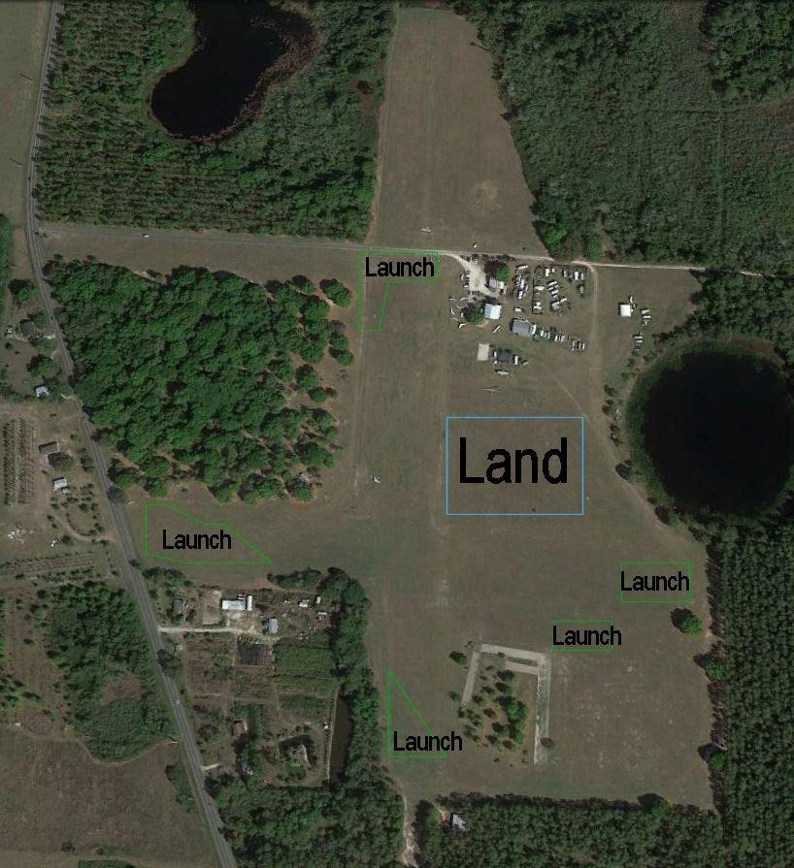

Launching - green
Designated Landing – light blue
The designated landing area is the area east of the runway when launching from the north end or on the south half of the runway.
The designated landing area is the area to the east of the runway when launching from the south end or at the north half of the runway.
The designated landing area is the area to the north of the runway when launching from the west end.

8. Designated Goals

All goals will be discussed at the pilot briefing. All obstacles and hazards associated with the goals and getting to the goals with be highlighted. Satellite photos of the goals and surrounding area and named obstructions for airfields found at http://www.airnav.com/airport/ will be presented.

The airfields are very lightly used. We instruct pilots not to cross the runways. We don’t land on the paved runways or taxi ways. If there is an obvious approach area we inform pilots of that at the pilot briefing.

We call the airports in advance to make sure that we have permission to land there. We ask them about any operations that would be ongoing that day and the approach pattern for the wind conditions. We tell pilots where to land, where the wind sock is located if it is an airfield goal.

All our goals are either airfields, fields associated with airfields, or hang-gliding flight parks. We therefore have access to detailed information about the airfields and what obstacles there may be, which will be presented to the pilots. Pilots are not required to land at these fields and may land at nearby fields.

Wallaby Ranch:
Coordinates: N28°15.179' W081°41.131'

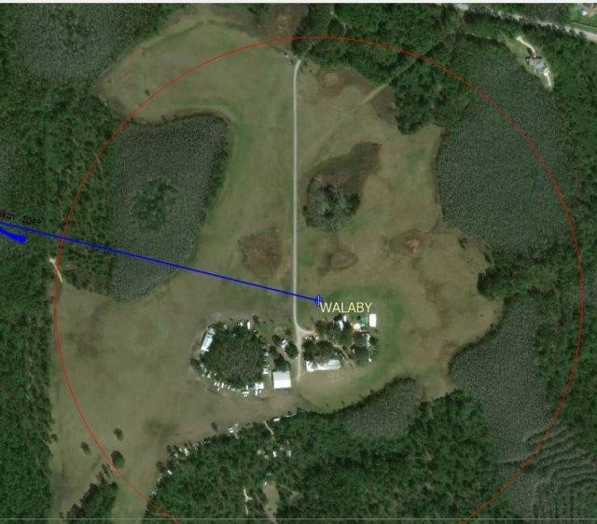

Flight park, 400-meter cylinder. Land away from any aerotowing operation.

Inverness:
Coordinates: N28°48.467' W082°19.094'
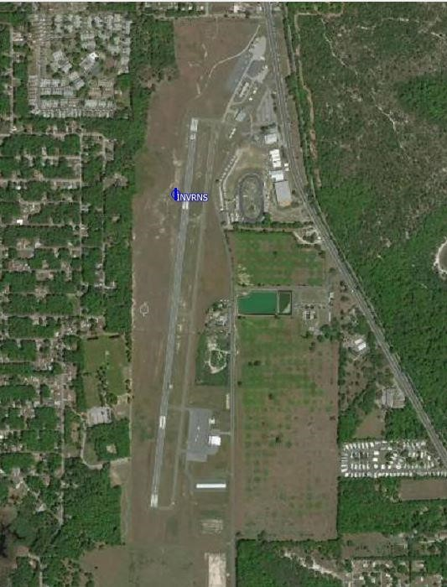 Public airfield, north/south runway, 400-meter cylinder, land parallel to the runway on either side.
Cheryl:
Coordinates: N28°40.286' W082°05.231'
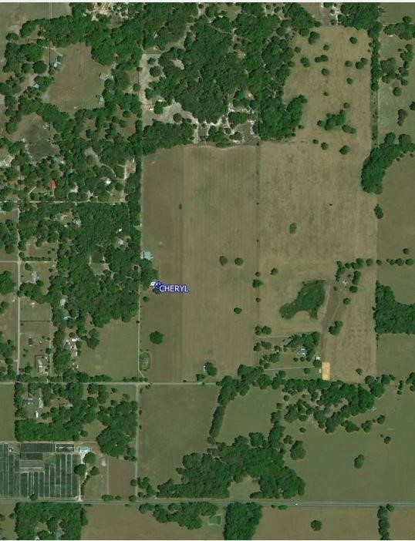
Open pasture, 400-meter cylinder, land preferably on the west side of the north/south fence line
Dunnellon:
Coordinates: N29°03.626' W082°22.539'

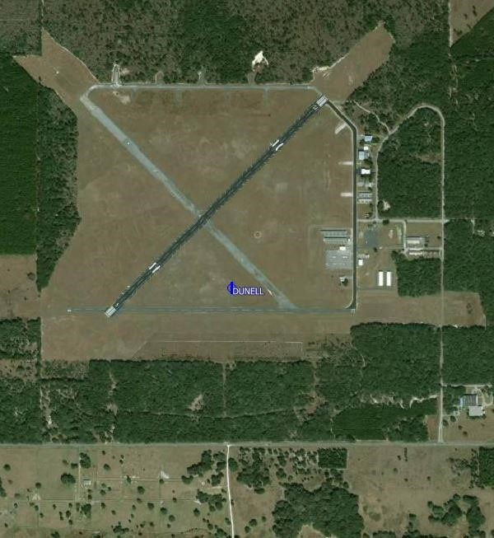

Large public airfield, 400-meter cylinder, land any where that goes directly into the wind

Leeward:
Coordinates: N29°05.058' W082°01.925'

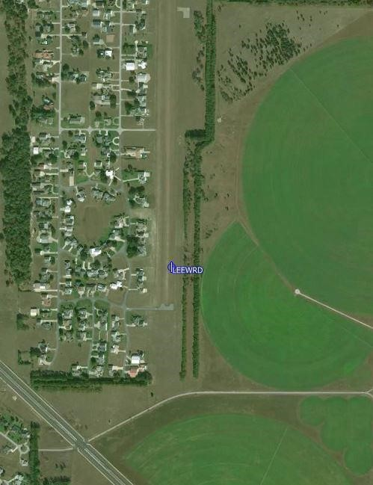

Private airfield, no landing there. Land in the fields on the south east or west, 1000meter cylinder.
Gross:
Coordinates: N28°38.733' W082°13.139'

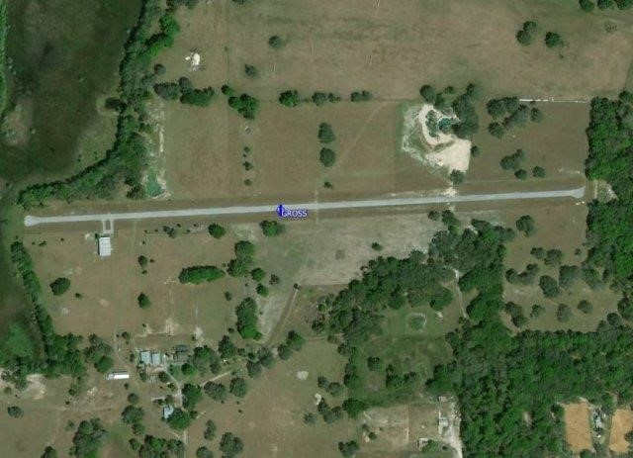

Private runway, 400-meter cylinder, land in the direction that is into the wind

9. Emergency Response Plan (Appendix A)

D. EMS - 911
The following guidelines have been established to assist the Meet and Safety Directors in effectively responding to an emergency. They should consider delegating responsibilities to competent individuals and take the following actions in the event of an accident:
- Meet Director takes command at the scene until relieved by a higher trained medical person. Ensure that this person understands that they are now in command.
- Meet Director immediately suspends towing operations to attend to the injured person.
- If First Aid personnel are not available, utilize staff and pilots to provide the following assistance:
  - Clear the air passage to enable breathing.
  - Apply firm pressure on the wounds to stop any bleeding.
- Safety Director obtains a quick assessment and calls EMS at 911 if the individual fails to meet any of the following criteria:
  - Is the individual breathing?
  - Does the individual have a pulse and good color?
  - Is the individual conscious and oriented to person, place and time?
  - Does individual have control of extremities and ability to wiggle fingers and toes?
  - Is individual free from back or neck pain?
- Safety Director provides EMS Dispatcher with the following on request:
  - Nature of incident: (ie hang gliding accident)
  - Nature of injury: (ie. Unconscious)
  - Location: (Quest Air Soaring Center on Groveland Airport Rd, just off State
Hwy 33 and 1.5 miles south of the intersection with State Hwy 50)
  - Name and approximate age
  - Caller cell phone number
  - Continue to answer questions and stay on the phone until released by the dispatcher.
- Launch Director ensures that a path is cleared for emergency response vehicles and personnel.
- Once relieved of command, the Meet Director investigates the accident by implementing the Incident Information Collection Form (Appendix B) and CIVL Incident Report Form are used as part of the response. These forms are printed and used to collect the incident reports in the field for later use in filling out the on-line reports.
- .

Appendix A Emergency Response Plan

Dial 911

Meet Director
- Take command at the scene until relieved by a higher trained medical person.
- Immediately suspend towing operations.
- Utilize staff and pilots to provide assistance until the First Responders arrive:
  - Clear the air passage to enable breathing.
  - Apply firm pressure to any wounds to stop the bleeding.
- Investigate the accident by implementing the Incident Information Collection Form (Appendix B) and CIVL Incident Report Form are used as part of the response. These forms are printed and used to collect the incident reports in the field for later use in filling out the on-line reports.
- .

Safety Director
- Perform a quick assessment and call EMS at 911 if the individual fails to meet a POSITIVE RESPONSE to any of the following criteria:
  - Is the individual breathing?
  - Does the individual have a pulse and good color?
  - Is the individual conscious and oriented to person, place and time?
  - Does individual have control of extremities (ability to wiggle fingers/toes)?
  - Is individual free from back or neck pain?
- Provide EMS Dispatcher with the following on request:
  - Nature of incident: (i.e. hang-gliding accident)
  - Nature of injury: (i.e. Unconscious)
  - Location: Sheets field, Groveland Airport Road 1.5 miles south of highway 50 on highway 33.
  - Name and approximate age
  - Callers cell phone number
  - Continue to answer questions and stay on the phone until released by the dispatcher.
Launch Director ensures that a path is cleared for emergency vehicles and personnel.

Appendix B
Incident information Collection Form
Provide the following information for the incident investigation:
Location: Time/Date:
Nature of Incident (check all that apply):
o Injury Pilot | o Injury Spectator | o Property Damage | o Non-Injury
o Fatal | o Hospital Visit | o Hospital Overnight | o Immediate Care
o Flying | o Non-Flying | o Hang Glider | o Solo Pilot
o Aerotowing | o At Launch | o At LZ | o XC
o Mid-Air | o Aerobatics | o Parachute Thrown

Persons Injured:
Name: | Name:
Address: | Address:
Cell Phone: | Cell Phone:
Email: | Email:
Injury Description: | Injury Description:

Pilots Involved:
Name: | Name:
Address: | Address:
Cell Phone: | Cell Phone:
Email: | Email:
USHPA #: | USHPA #:

Witness Information:
o Saw Incident | o On site | o Saw  Just  Before | o Saw Just After |  | o Saw Pilot Setting Up
o Saw Pilot  Launching | o Saw Pilot Landing | o Spoke  to pilot before | o Attended to pilot |  | o
Name: |  |  |  | Address:
Cell Phone: |  |  |  | Email:
I (witness) personally saw, heard. And/or observed the following:

Date: Witness Signature:

Appendix C Issuing a NOTAM

- Call the NOTAM Flight Service Office at 877 487-6867
- Provide your Name: Cell number:
- Activity: hang gliders operating out of the Sheets airfield (28°32.137', 081°50.760')
- Within a _____NM radius of this location (for tasks ending back at Wilotree Park)
OR
- _____NM either side of a line from Wilotree Park (28°32.137', -081°50.760') to
  - Next Waypoint Coordinates N__________ W_________ to
  - Next Waypoint Coordinates N__________ W_________ to
  - Next Waypoint Coordinates N__________ W_________ to (add additional waypoints as needed) to
  - Goal coordinates N__________ W_________
- Altitudes: Surface to ________msl (maximum altitude) expected for the day
- From ______ -______ Eastern Daylight Time
- The FS person will issue a NOTAM number which can be viewed at https://Pilotweb.nas.faa.gov

Appendix D Hang Glider Pilot Aerotow Checklist
- Check that the glider has been pre-flighted.
- Check cart integrity; adequate air pressure in tires, keel support at proper height, glider hold down mechanism adjusted properly and wheels are straight.
- Check that glider is properly seated in cart saddles with wheels on the outside (if applicable) and keel is centered on the support.
- Perform a hang check.
    - Check that harness is connected to the glider main and backup hang loops and the carabiner is locked. If using a direct connect harness, check that harness is hooked in to direct connect system inside the sail.
    - Check proper height above bar.
    - Check that harness lines are straight, leg loops are connected, chest buckle is connected and parachute pins are in place.
    - Check that lines are fully retracted especially the pod harness line at the harness boot.
    - Check that helmet is buckled.
- Check that the bridle is free of all restrictions and is routed above the basetube.
    - Check bridle connection to release closure mechanism.
    - Check bridle line for knots.
    - Check weak link(s) and replace if necessary.
- Check glider VG line is set for anticipated tow speed and desired bar pressure and is properly stowed.
- Check instruments are properly attached to base/downtubes and turned on.
- Check that all electronics (radio, phone, camera) are on and working properly.
- Connect tow rope to bridle. Check tow rope clip for proper closure.
- Signal for "take up slack”.
- Check final line tight configuration of release, bridle, tow rope and clip for routing, knots and assembly/closure.
- Check tow rope is clear and no knots are visible.
- Check that wind conditions are suitable for launch.
- Check for air traffic.
- Mentally prepare for tow and emergency actions.
- Say "Go go go!" to start the launch.
REMEMBER, as the pilot of a Hang Glider, YOU are responsible for checking everything! A crew person is only an assistant, and a second pair of eyes. Attention to detail is paramount. Should there be any problem that you did not catch, you must take responsibility for your own safety! Releasing is the only way to abort a tow!

Appendix D
Pilot Checklist Short Version
  - Glider pre-flight complete
  - Cart pre-flight complete
      - Wheels straight, tires pressurized and rotating freely
      - Saddles centered and hold down hose connected
      - Keel support adjusted properly
  - Glider seated on saddles and keel support
  - Harness Check complete
      - Main and backup loops connected
      - Leg loops and chest buckles connected
      - Parachute pins in place
      - Harness lines straight and retracted (check boot)
      - Helmet buckled
  - Bridle and weak link check complete
  - Instrument on and radio check complete
  - VG cord set and stowed
  - Tow line connection and “line tight” check complete
  - Launch conditions check complete

Appendix E Dragonfly Checklist

Preflight Check (The same type of inspection should be done as Post Flight Inspection)

Every time the plane is prepared for flight the entire aircraft must be subjected to a pre-flight check whereby the pilot visually checks the aircraft to ensure that the aircraft is in a condition for “Safe Operation”.
Conduct the pre-flight check as a walk around the aircraft starting at the same point each time, to ensure that every part of the structures, cables, attachments and components are inspected. Every part or component must be free of excessive wear, defect, tears, cracks, Loose or missing bolts, hardware etc. etc. refer to Figure 4 Pre-Flight Areas.

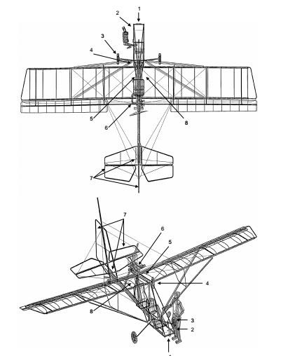

1.1 Aircraft and engine controls

For each seat check that the rudder pedals and stick move freely into all extreme positions. Check the links and connections on the stick and rudder to ensure that they are connected correctly and secured.

Check the condition of the seats and check that the seatbelts are securely fastened. Check that the fuel tank is securely fastened and with the cap screwed tight and containing the sufficient amount of fuel for the intended flight time.

1.2 Instruments

Check the Pitot tube orifice is clear of obstructions. (A simple test can be done to check that airspeed indicator works by blowing from several inches away, across the Pitot tube, NEVER BLOW DIRECTLY INTO THE PITOT TUBE
as this can permanently damage the ASI & ALT instruments. Ensure that the indicator returns to zero position.) Check the correct indicating positions of the other instruments also.

1.3 Undercarriage and main wheels
Check (visually and by hand) that the tires have the correct air pressure. Check that the tires are free of any damage. Check that the wheel nuts are in place and not loose, and that the undercarriage legs/axles are securely fastened to the fuselage.

1.4 Emergency parachute

Check that the emergency parachute is securely fastened to the aircraft with the cover sitting in the correct position and with the bridle secured around the main root tube. Remove the safety pin from the release handle and stow in a secure position. Re Insert the safety pin in Post Flight Inspection. Minimum Pressure 4200 psi

1.5 Left part of the wing

Remove the inspection panel behind the parachute and inspect the inside of each side of the wing ensuring that all battens are in place and that all tubing and support cables are undamaged. Replace the inspection panel and secure using the Velcro strips. Check that the Dacron wing surface is free of holes or other damage. Check that each end
of the strut and outside support cables are securely fastened on the fuselage, tail and wing respectively.
Check that the aileron is securely fastened to the wing and that it moves freely between the extreme positions. Check that the linkages and connections to the control surface are securely fastened.

1.6 Engine and propeller (Left Side)

Check that the propeller is free of damage, especially delamination of the composite material. Check that the engine and muffler is securely fastened to the engine assembly plate and that this is securely fastened to the aircraft. Ensure that all safety wires are in place as required on the propeller, gearbox and engine bolts. Check that the oil tank and the radiator are filled to proper level (overflow bottle should have fluid at minimum mark cold) and check that the ignition cables are securely in place on the spark plugs. Insure Propeller bolts are secure, and inspect prop for damage.

1.7 Tail

Check that the rudder and elevator moves freely between the extreme positions.
Check that the linkage and connections for the control surfaces are securely fastened. Check (visually) that the tail wheel tire has the correct air pressure and is free of damage. Check that the wires from the rudder pedals are connected correctly to the steering plate. And that supporting cables are free of defect or wear.

Repeat 1.6 Engine and propeller for Right Side of Engine

1.8 Right part of the wing. Same as for the inspection of the left wing. 1.5 above

Inspect each side of the wing ensuring that all battens are in place and that all tubing and support cables are undamaged. . Check that the Dacron wing surface is free of holes or other damage. Check that each end of the strut and outside support cables are securely fastened on the fuselage, tail and wing respectively.
Check that the aileron is securely fastened to the wing and that it moves freely between the extreme positions. Check that the linkages and connections to the control surface are securely fastened.

2 Engine starting

WARNING: Do Not attempt Hand starting by turning the propeller, it is Very Dangerous. Always use the electric start system.

FUEL: Approved types of fuel, 90+ octane quality unleaded auto gasoline (10% ethanol is approved) (No
Methanol Content). * (use of 100 LL may require additional provisions listed in current Rotax manuals) * refer to Rotax Operators Manual or www.flyrotax.com for current recommendations.
OIL: 582 Approved* types and brands of TCW-III mixed 50:1
912 Approved* types and brands listed in the Current Rotax 912 manuals * refer to Rotax Operators Manual or www.flyrotax.com for current recommendations.

STARTING THE ENGINE;

- Ensure rear seat belt is fastened so that it will not fly into prop and no other item is loose that will be drawn into the propeller stream.
- Pump fuel to the carburetors by operating the squeeze bulb in the fuel line till the bulb is firm.
- Ensure that the throttle is in Idle Position (Closed)
- Choke on (Cold Start)
- Check that prop is clear of bystanders.
(When you are ready, look both sides and call loudly “CLEAR PROP”)
- Ensure that the front of the aircraft is clear.
- Operate brakes. (On)
- 582 Pump bulb until it becomes hard. Pump primer 2-3 times.
912 Equipped with Electric Boost Pump, run pump until fuel is seen returning to tank through the return line.

- Call “CLEAR PROP” to warn observers, & look to insure it is clear.

- Turn IGNITION Switches ON and Press Starter Switch to Start.

Normally the engine will start within 2 seconds. Do not crank the engine more than 10 seconds if it does not start. Longer operation may overheat the starter motor.

(582 only -- Cold conditions require more priming. Pump primer twice more and try again.)
The behavior of the engine will indicate the problem. In most cases it is too much or too little fuel to suit the temperature.

Should the engine not start after three or four attempts then it is possible that the engine is flooded with fuel. To balance this situation, open the throttle to allow more air to be drawn in.

CAUTION: With the throttle open the aircraft may surge forward when it starts. Be ready to Close Throttle.

Operate the starter with one hand on the throttle to immediately pull the throttle back to idle or low power if the engine starts and be ready to SWITCH OFF if an emergency arises.

When the engine starts allow it to idle at 2000 – 2200 rpm for a full minute or longer to allow the engine to reach operating temperature. Let the engine warm up properly before applying too much power!
582 Coolant to 140 degrees F, before exceeding 3000 rpm’s.
912 Oil Temperatures to 120 degrees F, before exceeding 3000 rpm’s.
IMPORTANT NOTE: A thorough warm up is essential to the longevity to the engine life and performance.

4.3 Taxiing

The Rudder pedals operate rudder and tail wheel steering. Control is easy and turning radius is average. Taxiing in cross wind up to 15 mph creates no problem.
Both the rudder and tail wheel turn the aircraft in the same direction.

For a left turn PUSH LEFT PEDAL
For right turn PUSH RIGHT PEDAL

At times Low Speed Taxiing can be improved by pulling up elevator to hold the rear wheel firmly on the ground. When taxiing down wind keep the stick in Neutral Position.
When attempting to taxy across wind lean the stick into the wind to reduce lift on the upwind flaperon. Failure to keep the aircraft balanced can lead to Ground Loops.

Maps of Wilotree Park
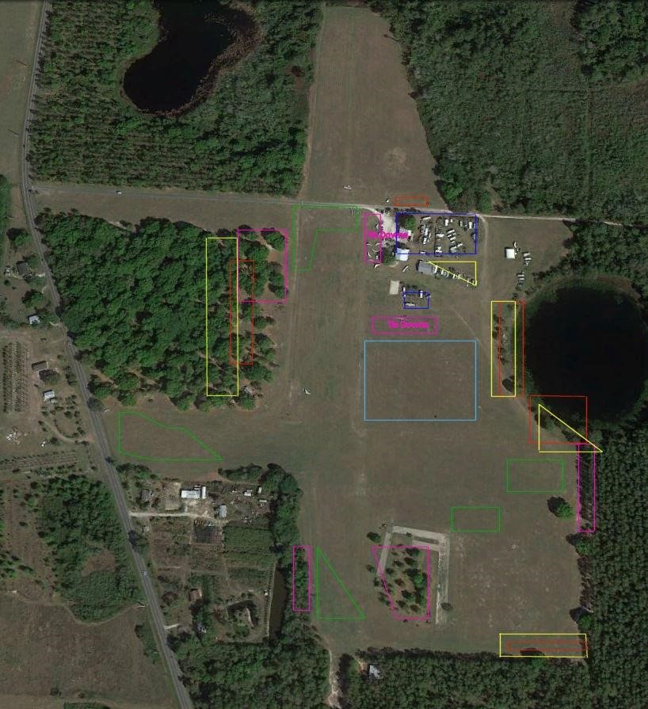
1

Parking
-

red

Resident Parking – dark blue
Camping - yellow
Setup - violet
Launching - green
Designated Landing – light blue
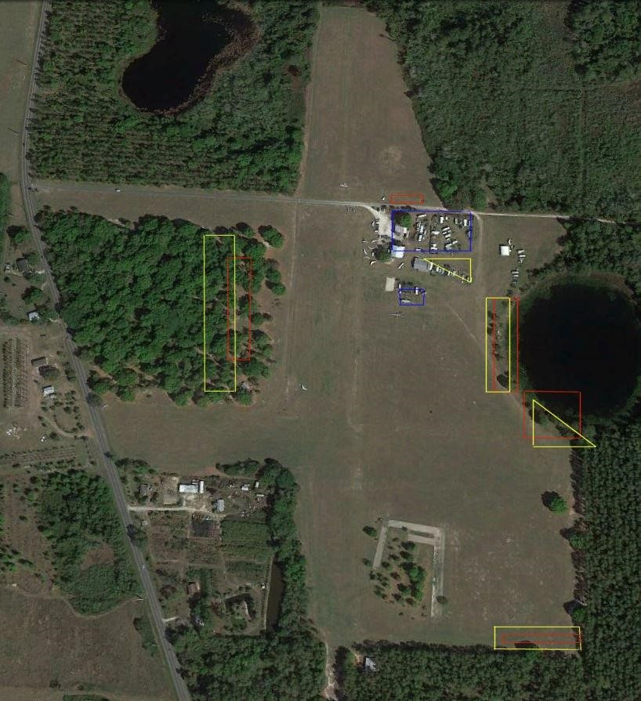
Parking - red
Resident Parking – dark blue
Camping – yellow
You can camp in the trees, west of the main hangar, next to the lake, or in the southeast corner. Spectator parking will be north of Groveland Airport Road and due north of the club house.

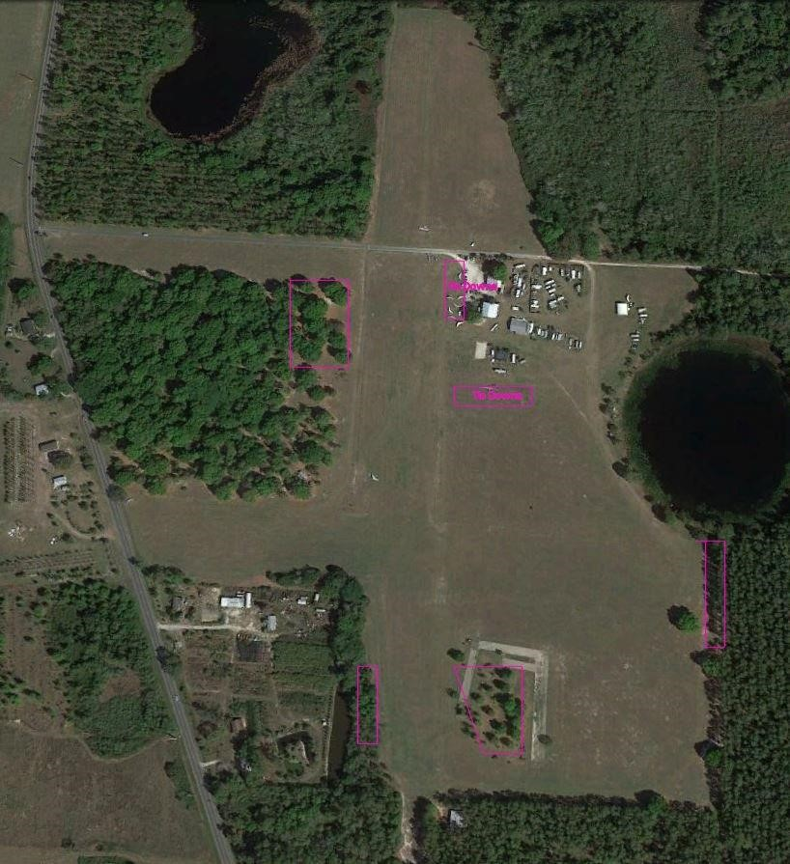
Setup – violet
The two main setup areas near the club house and pool have tie downs. All other setup areas will require the pilot to provide their own tie downs.

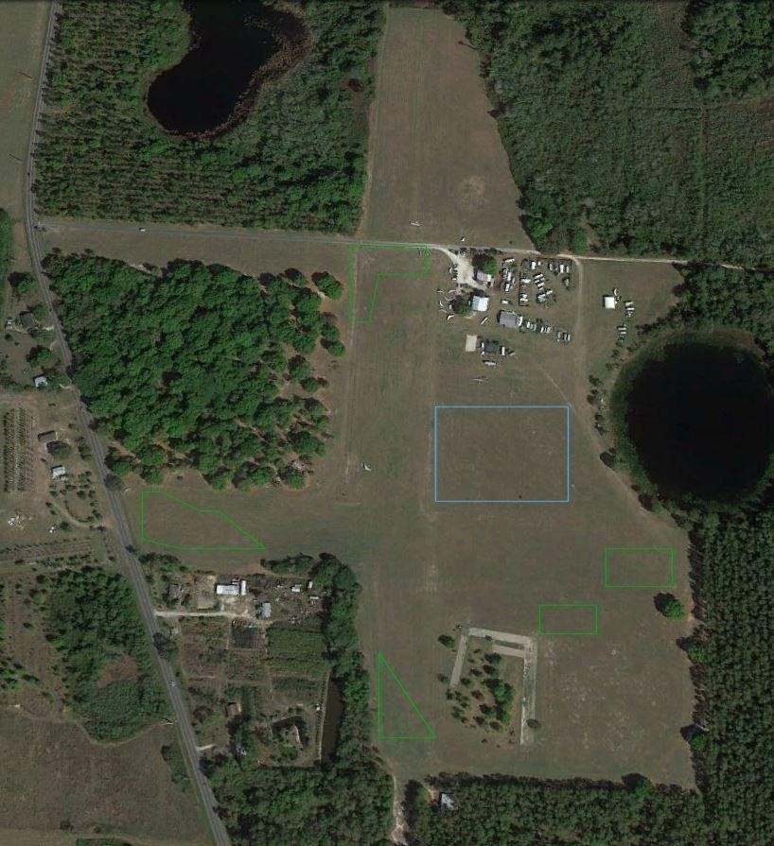
Launching - green
Designated Landing – light blue
The designated landing area is the area east of the runway when launching from the north end or on the south half of the runway.
The designated landing area is the area to the east of the runway when launching from the south end or at the north half of the runway.
The designated landing area is the area to the north of the runway when launching from the west end.
The designated landing area is the area is the area to the north of the runway when launching from the east end or the far end of the east/west runway.
When landing back at Wilotree Park during aerotow operations stay clear of the Dragonfly landing pattern.

