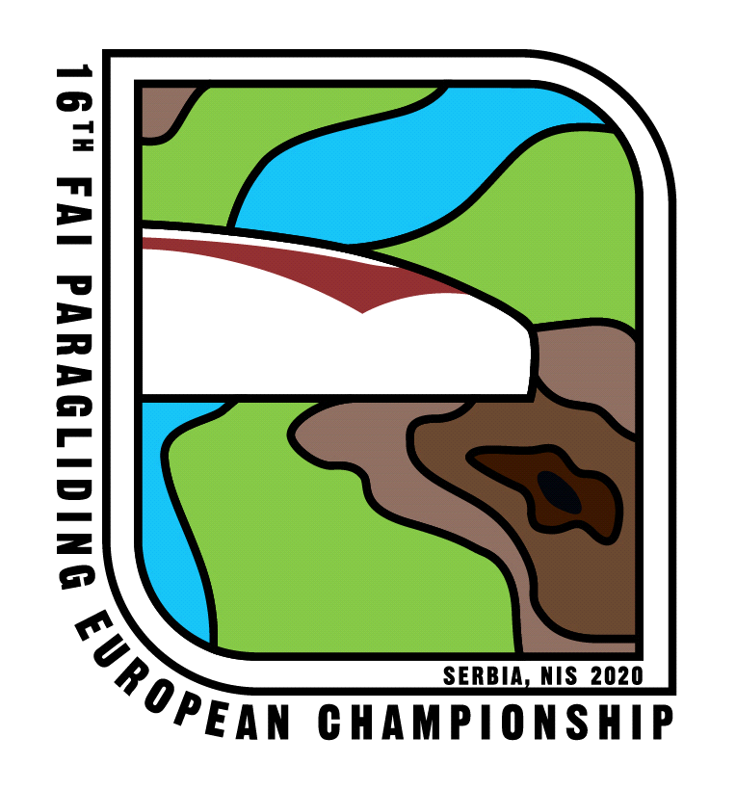
ENTRY FORM FOR

16th FAI Paragliding European Championship
July19th - August 01, 2020, Nis, Serbia

Name of National Aero Club__________________________________________________________
Address ____________________________________________________________________
Tel/fax; email _______________________________________________________________
We wish to enter the following competitors who qualify under the FAI Nationality or Residence Rules (General Section 3.7.) and will fly a paraglider of the correct class for the championship:

Pilot  Name, Surname | Nat/Res | Age | Sex | Comp. Class | Sporting  Licence n° | CIVL  Pilot ID | Pilot Qualification IPPI card

Note: ___________________________________________
NAC’s are invited to submit applications for pilots in high enough numbers, so they can be included in case of extra allocation rounds.

TEAM LEADER
Name, surname

Email:

Contact Telephone number:

Names/number of Assistants if known

_______________________________________________________________________

_______________________________________________________________________

ENTRY FEES.

For each pilot - €
For each assistant - €
For the Team Leader - €

Total____________

This amount will be paid in Euros by end date as per the Local Regulations of the Event.
I/We declare that the above information is true, and that all the pilots meet the required qualifications for entry to this competition (evidence attached) as per Section 7A.
I/We have read the Local Regulations for the Events, understood and comply with the related provisions.

Signed _______________________________________________

Date _______________________ _________________________

Name _______________________________________________

Position in NAC ______________________________________________

Please send this form to
office@vss.rs and sport@vss.rs

