NOTICE TO ALL APPLICANTS
By applying for this insurance, the applicant is also applying for membership in Recreation Risk Retention Group, Inc., a risk retention group formed and operating pursuant to the Liability Risk Retention Act of 1986 (15 USC 3901 et. Seq.).
NOTICE
This policy is issued by your risk retention group. Your risk retention group may not be subject to all of the insurance laws and regulations of your state. State insurance insolvency guaranty funds are not available for your risk retention group.
126 COLLEGE ST. STE. 400
BURLINGTON, VT 05401
802­383­1541 applications@recreationrrg.com

Tow Device Supplement Application - AEROTOW DEVICE
Complete a Separate Tow Device Supplement Application for Each Tow Device Used in Applicant's Operations
PLEASE READ EACH QUESTION CAREFULLY AND PROVIDE COMPLETE, TRUTHFUL AND ACCURATE RESPONSES. THE INFORMATION REQUESTED IN THIS APPLICATION IS IMPORTANT TO THE UNDERWRITING PROCESS. ANY MATERIAL MISREPRESENTATION MAY AFFECT THE INSURANCE POLICY ISSUED BASED ON THIS APPLICATION.
CHAPTER IDENTIFICATION
NAMED INSURED: United States Hang Gliding And Paragliding Association, Inc.
NAME OF USHPA EVENT THAT USES TOW DEVICE: 2018 Quest Air National Series
1. AERO TOW PLANE IDENTIFICATION AND INFORMATION
1.1 See attached
Make: |  |  |  | Model: |  |  |  | Year:
1.2 See attached
FAA Registration Number: |  |  |  | Registered Owner:
1.3 See attached
Do you use a weak link? |  |  |  |  |  |  |  Yes |  |  |  No
If Yes, Describe the
Weak Link used
AND Attach Photo(s):
 | If No, Please Explain:
1.4 See attached
Describe the Tow Release(s) used and Attach Photo(s):
1.5 See attached
Describe the Tow Bridle(s) used and Attach Photo(s):

1.6 See attached
Do you use a Pre-Flight Checklist for the Tow Plane? |  |  |  |  |  |  Yes |  No
 | If Yes, Attach Copy
 | If No, Please Explain:
1.7 See attached
Do you keep maintenance logs for your Tow Plane? |  |  |  |  |  |  Yes |  No
 | If Yes, Attach Copy
 | If No, Please Explain:
1.8 See attached
Describe the Tow Line used
(Material, Strength, Length, Etc...)
AND Attach Photo(s):
2. AERO TOW PILOTS (All tug pilots MUST be listed)
NAME |  |  | AGE | LIST EXPERIENCE FLYING TUG | FAA LICENSE # (Attach Copy)
See attached
3. LAUNCH EQUIPMENT
3.1 See attached
Do you use a Written Pre-Launch Checklist? |  |  |  |  |  |  Yes |  No
 | If Yes, Attach Copy
 | If No, Please Explain:
3.2 See attached
Describe tow dolly used, including, angle of attack adjustment mechanism, cart to-glider hold down system, etc. . . .
AND Attach Photos:

4. HANG GLIDING EQUIPMENT
See attached
Describe each of the following Glider Systems as you utilize them in your towing operation AND Attach Photos |  | SOLO GLIDERS ON TOW |  | TANDEM GLIDERS ON TOW
4.1 Wheel Systems
4.2 Tow Bridle
4.3 Attachment Points
4.4 All Release Mechanisms
4.5 Harness(es)
4.6 Accessory Equipment
Mounted on Glider(s)
(for example, cameras, varios,
wind meters, hook knives, etc . . .)
5. AEROTOW PROCEDURES
Do you have an Aerotow Training Syllabus which you utilize in your operation? See attached |  |  |  |  |  Yes |  No
 | If Yes, Attach Copy
 | If No, Explain:
6. VIDEO OF AEROTOW OPERATIONS
6.1 Provide Video footage of your typical TANDEM launch |  |  |  |  | N/A
6.2 Provide Video footage of your typical SOLO launch
See attached
I understand the information submitted herein becomes a part of USHPA's Insurance Application, and is subject to the same warranty and conditions.
Any person who knowingly and with intent to defraud any insurance company or other person, files an application for insurance containing any false information, or conceals for the purpose of misleading, information concerning any fact material thereto, commits a fraudulent insurance act.
SIGNATURE OF USHPA OFFICER: |  |  | TITLE |  | DATE
SIGNATURE OF COMPETITION ORGANIZER: |  |  | TITLE: Meet organizer |  | DATE:

Section 1.1, 1.2, and 2.0 Summery Table

Make | Model | Manu | FAA Reg | Owner | Authorized pilots
 |  | Date
Bailey-Moyes | 582 Dragonfly Experimental | 2001 | N575KH | Entertainment ETC LLC | All except Gregg Ludwig*
Bailey-Moyes | 914 Dragonfly Experimental | 2004 | N2646C | Russel Brown | All except Gregg Ludwig*
Bailey-Moyes | 914 Dragonfly Experimental | 2001 | N2647C | Russel Brown | All except Gregg Ludwig*
Bailey-Moyes | 914 Dragonfly Experimental | 1994 | N2650C | Russel Brown | All except Gregg Ludwig*
Bailey-Moyes | 914 Dragonfly Experimental | 2005 | N2630C | Russel Brown | All except Gregg Ludwig*
Bailey-Moyes | 582 Dragonfly Light Sport | 2010 | N942DF | Robert Bailey | All except Gregg Ludwig*
Bailey-Moyes | 582 Dragonfly Experimental | 2007 | N800HG | Joel Froehlich | All except Gregg Ludwig*
Aeros | XC Cross Country Experimental | 2003 | N5004D | Gregg Ludwig | Gregg Ludwig
Bailey-Moyes | 532 Dragonfly Experimental | 2007 | N70679 | Gregg Mcnamee | All except Gregg Ludwig*
Bailey-Moyes | 582 Dragonfly Experimental | 1997 | N346FL | KHK Morningside | All except Gregg Ludwig*
Bailey-Moyes | 912S Dragonfly Experimental | none | N618FR | James Tindle | All except Gregg Ludwig*
*All includes the following:
April Mackin, Mitch Shipley, Jim Prahl, Russell Brown, Jonny Thompson, Rhett Radford, Derrick Turner, Bobby Bailey, Joel Froehlich, Steve Flynn, EVGENIYA LARITSKAYA, and Mick Howard.

Section: 1.1,2 TOW PLANE IDENTIFICATION AND INFORMATION:
FAA Registration Number: N575KH
FAA REGISTRY

Aircraft Description
Serial Number | 1RWT | Status | Valid
Manufacturer Name | MOYES | Certificate Issue Date | 12/12/2011
Model | DRAGONFLY | Expiration Date | 12/31/2017
Type Aircraft | Fixed Wing Single-Engine | Type Engine | 2 Cycle
Pending Number Change | None | Dealer | No
Date Change Authorized | None | Mode S Code (base 8 / oct) | 51660745
MFR Year | 2001 | Mode S Code (base 16 / hex) | A761E5
Type Registration | Corporation | Fractional Owner | NO

Registered Owner
Name | ENTERTAINMENT ETC LLC
Street | 17921 PHIL C PETERS RD
City | WINTER GARDEN | State | FLORIDA
County | POLK | Zip Code | 34787-9740
Country | UNITED STATES

Airworthiness
Engine Manufacturer | ROTAX | Classification | Experimental
Engine Model | 582 | Category | Reg. Prior to 01/31/08
A/W Date | 04/21/2011
Section: 1.7

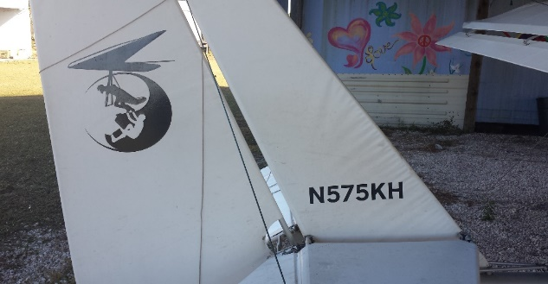
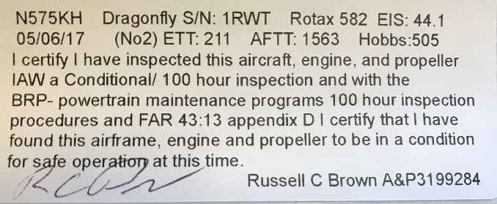
April states that her plane has not been flown since the Midwest 2017 and is still within the 100 hours.

Section: 1.1,2 FAA Registration Number: N2646C

FAA REGISTRY

Aircraft Description
Serial Number | 0017 | Status | Valid
Manufacturer Name | BROWN RUSSELL C | Certificate Issue Date | 08/28/2007
Model | BAILEY-MOYES DRAGONF | Expiration Date | 02/28/2018
Type Aircraft | Fixed Wing Single-Engine | Type Engine | 4 Cycle
Pending Number Change | None | Dealer | No
Date Change Authorized | None | Mode S Code (base 8 / oct) | 50510406
MFR Year | 2004 | Mode S Code (base 16 / hex) | A29106
Type Registration | Individual | Fractional Owner | NO

Registered Owner
Name | BROWN RUSSELL C
Street | 6217 DEWEY ROBBINS RD
City | HOWEY IN THE HILLS | State | FLORIDA
County | LAKE | Zip Code | 34737-4017
Country | UNITED STATES

Airworthiness
Engine Manufacturer | ROTAX | Classification | Experimental
Engine Model | 914 (SERIES) | Category | Reg. Prior to 01/31/08
A/W Date | 02/12/2010

Section: 1.7
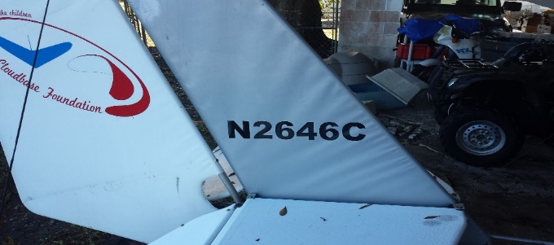
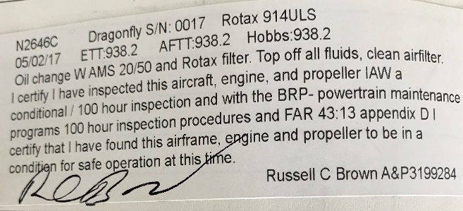

Section: 1.1,2 FAA Registration Number: N2647C

FAA REGISTRY

Aircraft Description
Serial Number | 0016 | Status | Valid
Manufacturer Name | BROWN RUSSELL C | Certificate Issue Date | 08/28/2007
Model | BAILEY-MOYES DRAGONF | Expiration Date | 02/28/2018
Type Aircraft | Fixed Wing Single-Engine | Type Engine | 4 Cycle
Pending Number Change | None | Dealer | No
Date Change Authorized | None | Mode S Code (base 8 / oct) | 50510451
MFR Year | 2001 | Mode S Code (base 16 / hex) | A29129
Type Registration | Individual | Fractional Owner | NO

Registered Owner
Name | BROWN RUSSELL C
Street | 6217 DEWEY ROBBINS RD
City | HOWEY IN THE HILLS | State | FLORIDA
County | LAKE | Zip Code | 34737-4017
Country | UNITED STATES

Airworthiness
Engine Manufacturer | ROTAX | Classification | Experimental
Engine Model | 914 (SERIES) | Category | Reg. Prior to 01/31/08
A/W Date | 02/12/2010

Section: 1.7
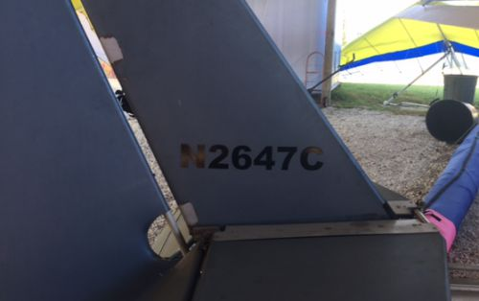
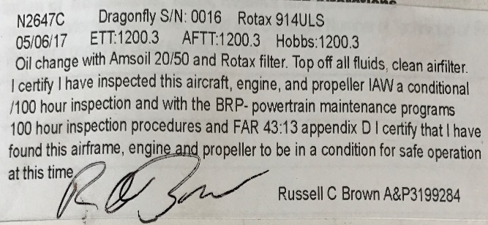
Section: 1.1,2 FAA Registration Number: N2650C

FAA REGISTRY

Aircraft Description
Serial Number | 0019 | Status | Valid
Manufacturer Name | BAILEY ROBERT | Certificate Issue Date | 08/28/2007
Model | BAILEY-MOYES DRAGONF | Expiration Date | 02/28/2018
Type Aircraft | Fixed Wing Single-Engine | Type Engine | 4 Cycle
Pending Number Change | None | Dealer | No
Date Change Authorized | None | Mode S Code (base 8 / oct) | 50511753
MFR Year | 1994 | Mode S Code (base 16 / hex) | A293EB
Type Registration | Individual | Fractional Owner | NO

Registered Owner
Name | BROWN RUSSELL C
Street | 6217 DEWEY ROBBINS RD
City | HOWEY IN THE HILLS | State | FLORIDA
County | LAKE | Zip Code | 34737-4017
Country | UNITED STATES

Airworthiness
Engine Manufacturer | ROTAX | Classification | Experimental
Engine Model | 914 (SERIES) | Category | Reg. Prior to 01/31/08
A/W Date | 02/12/2010

Section: 1.7

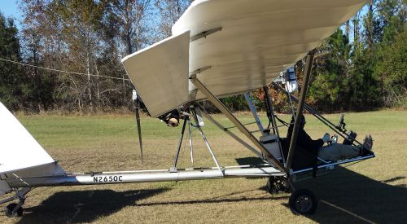
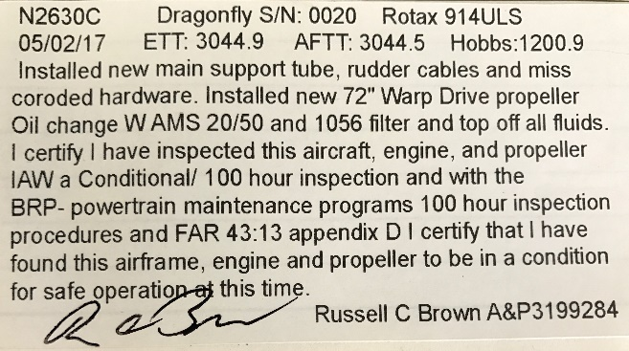

Section: 1.1,2 FAA Registration Number: N2630C

FAA REGISTRY

Aircraft Description
Serial Number | 0020 | Status | Valid
Manufacturer Name | BAILEY ROBERT | Certificate Issue Date | 08/28/2007
Model | BAILEY-MOYES DRAGONF | Expiration Date | 02/28/2021
Type Aircraft | Fixed Wing Single-Engine | Type Engine | 4 Cycle
Pending Number Change | None | Dealer | No
Date Change Authorized | None | Mode S Code (base 8 / oct) | 50506175
MFR Year | 2005 | Mode S Code (base 16 / hex) | A28C7D
Type Registration | Individual | Fractional Owner | NO

Registered Owner
Name | BROWN RUSSELL C
Street | 6217 DEWEY ROBBINS RD
City | HOWEY IN THE HILLS | State | FLORIDA
County | LAKE | Zip Code | 34737-4017
Country | UNITED STATES

Airworthiness
Engine Manufacturer | ROTAX | Classification | Experimental
Engine Model | 914 (SERIES) | Category | Reg. Prior to 01/31/08
A/W Date | 02/12/2010 | Exception Code | No

Section: 1.7
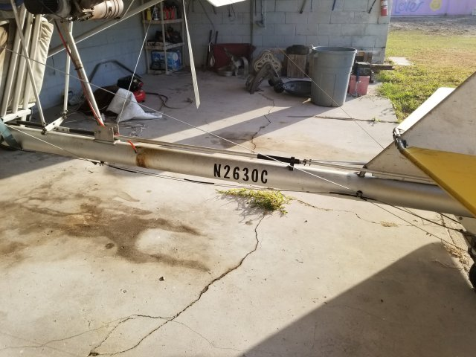
Information regarding the Annual/100 hour inspection will be completed by 3-15-18

Section: 1.1,2 FAA Registration Number: N942DF

FAA REGISTRY

Aircraft Description
Serial Number | PA-582-112 | Status | Valid
Manufacturer Name | PITMAN EDGAR D DBA PITMAN AIR | Certificate Issue Date | 11/13/2014
Model | DRAGONFLY 582 | Expiration Date | 11/30/2020
Type Aircraft | Fixed Wing Single-Engine | Type Engine | 2 Cycle
Pending Number Change | None | Dealer | No
Date Change Authorized | None | Mode S Code (base 8 / oct) | 53212347
MFR Year | 2010 | Mode S Code (base 16 / hex) | AD14E7
Type Registration | Individual | Fractional Owner | NO

Registered Owner
Name | BAILEY ROBERT E
Street | 6548 GROVELAND AIRPORT RD
City | GROVELAND | State | FLORIDA
County | LAKE | Zip Code | 34736-9685
Country | UNITED STATES

Airworthiness
Engine Manufacturer | ROTAX | Classification | Light Sport
Engine Model | 582UL | Category | Airplane
A/W Date | 02/26/2014 | Exception Code | No

Section: 1.7
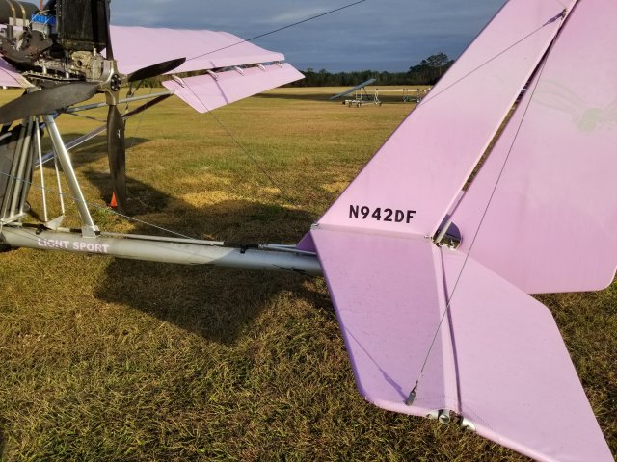
Information regarding the Annual/100 hour inspection will be provided by 3-15-18
Section: 1.1,2 FAA Registration Number: N800HG

FAA REGISTRY

Aircraft Description
Serial Number | 100 | Status | Valid
Manufacturer Name | LITEFLITE PTY LTD | Certificate Issue Date | 11/20/2007
Model | DRAGONFLY MODEL C | Expiration Date | 12/31/2018
Type Aircraft | Fixed Wing Single-Engine | Type Engine | 2 Cycle
Pending Number Change | None | Dealer | No
Date Change Authorized | None | Mode S Code (base 8 / oct) | 52561223
MFR Year | 2007 | Mode S Code (base 16 / hex) | AAE293
Type Registration | Individual | Fractional Owner | NO

Registered Owner
Name | FROEHLICH JOEL M
Street | PO BOX 1131
City | MCQUEENEY | State | TEXAS
County | GUADALUPE | Zip Code | 78123-1131
Country | UNITED STATES

Airworthiness
Engine Manufacturer | ROTAX | Classification | Experimental
Engine Model | 582UL | Category | Reg. Prior to 01/31/08
A/W Date | 01/05/2010

Section: 1.7
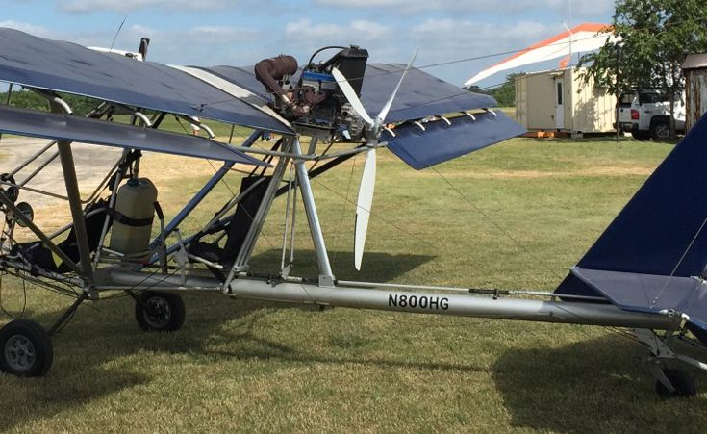

Information regarding the Annual/100 hour inspection will be provided by 3-15-18
.

T Section: 1.1,2 FAA Registration Number: N5004D

FAA REGISTRY

Aircraft Description
Serial Number | MBP0308047 | Status | Valid
Manufacturer Name | AEROS | Certificate Issue Date | 08/22/2013
Model | XC CROSS COUNTRY | Expiration Date | 08/31/2019
Type Aircraft | Weight-shift-control | Type Engine | Reciprocating
Pending Number Change | None | Dealer | No
Date Change Authorized | None | Mode S Code (base 8 / oct) | 51436330
MFR Year | 2003 | Mode S Code (base 16 / hex) | A63CD8
Type Registration | Individual | Fractional Owner | NO

Registered Owner
Name | LUDWIG GREGG A
Street | 29435 FOX RIVER DR
City | SPRING | State | TEXAS
County | MONTGOMERY | Zip Code | 77386-2396
Country | UNITED STATES

Airworthiness
Engine Manufacturer | AMA/EXPR | Classification | Experimental
Engine Model | UNKNOWN ENG | Category | Reg. Prior to 01/31/08
A/W Date | 09/22/2006

Section: 1.7
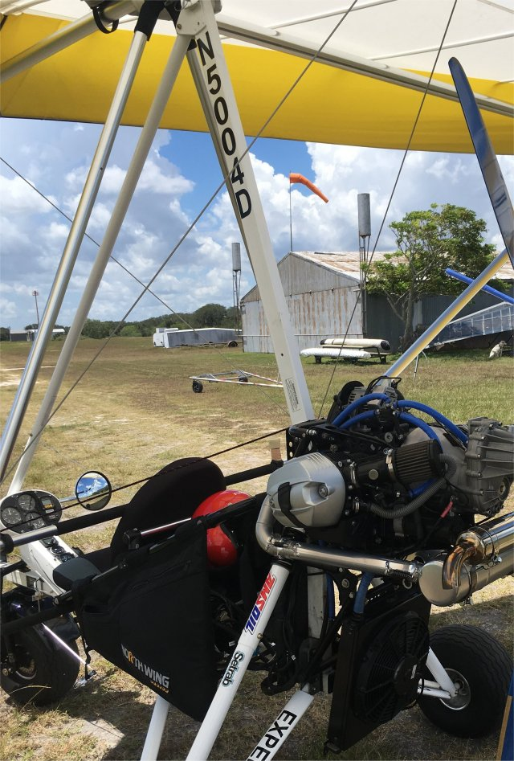
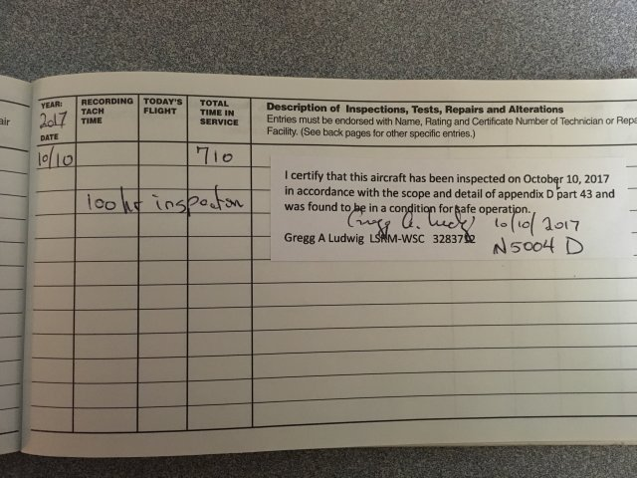

Section: 1.1,2 FAA Registration Number: N70679

FAA REGISTRY

Aircraft Description
Serial Number | 02 | Status | Valid
Manufacturer Name | BAILEY/MOYES DRAGONFLY | Certificate Issue Date | 08/16/2007
Model | A | Expiration Date | 04/30/2018
Type Aircraft | Fixed Wing Single-Engine | Type Engine | 2 Cycle
Pending Number Change | None | Dealer | No
Date Change Authorized | None | Mode S Code (base 8 / oct) | 52267107
MFR Year | 2007 | Mode S Code (base 16 / hex) | A96E47
Type Registration | Individual | Fractional Owner | NO

Registered Owner
Name | MCNAMEE GREGG B
Street | 14141 SE 51ST AVE
City | SUMMERFIELD | State | FLORIDA
County | MARION | Zip Code | 34491-3101
Country | UNITED STATES

Airworthiness
Engine Manufacturer | ROTAX | Classification | Experimental
Engine Model | 532 | Category | Reg. Prior to 01/31/08
A/W Date | 12/29/2007 | Exception Code | No

Section: 1.7
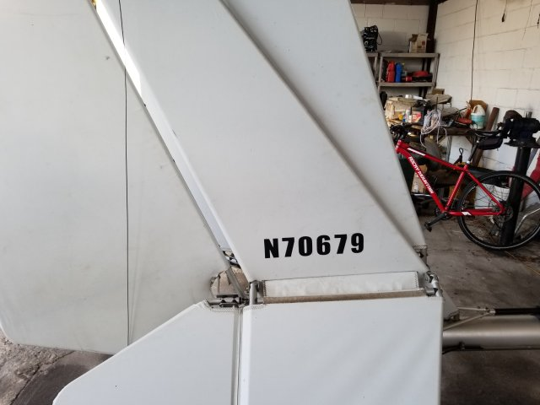
Information regarding the Annual/100 hour inspection will be provided by 3-15-18

Section: 1.1,2 FAA Registration Number: N346FL

FAA REGISTRY

Aircraft Description
Serial Number | 034 | Status | Valid
Manufacturer Name | BAILEY N MOYES | Certificate Issue Date | 06/07/2012
Model | DRAGONFLY | Expiration Date | 06/30/2018
Type Aircraft | Fixed Wing Single-Engine | Type Engine | 2 Cycle
Pending Number Change | None | Dealer | No
Date Change Authorized | None | Mode S Code (base 8 / oct) | 50752040
MFR Year | 1997 | Mode S Code (base 16 / hex) | A3D420
Type Registration | Corporation | Fractional Owner | NO

Registered Owner
Name | KHK MORNINGSIDE LLC
Street | PO BOX 1839
City | NAGS HEAD | State | NORTH CAROLINA
County | DARE | Zip Code | 27959-1839
Country | UNITED STATES

Airworthiness
Engine Manufacturer | ROTAX | Classification | Experimental
Engine Model | 582UL | Category | Reg. Prior to 01/31/08
A/W Date | 01/20/2010
Section: 1.7
No picture – No N number on plane, no 100 hour sign off

Section: 1.1,2 FAA Registration Number: N618FR

FAA REGISTRY

Aircraft Description
Serial Number | 20076181118MDF | Status | Valid
Manufacturer Name | MOYES BAILEY | Certificate Issue Date | 02/28/2017
Model | DRAGONFLY | Expiration Date | 02/29/2020
Type Aircraft | Fixed Wing Single-Engine | Type Engine | 4 Cycle
Pending Number Change | None | Dealer | No
Date Change Authorized | None | Mode S Code (base 8 / oct) | 52006403
MFR Year | None | Mode S Code (base 16 / hex) | A80D03
Type Registration | Individual | Fractional Owner | NO

Registered Owner
Name | TINDLE JAMES E
Street | 12671 E STATE ROAD 80
City | CLEWISTON | State | FLORIDA
County | HENDRY | Zip Code | 33440-7595
Country | UNITED STATES

Airworthiness
Engine Manufacturer | ROTAX | Classification | Experimental
Engine Model | 912S | Category | Operating Light-Sport Prev. issued cert under 21.190
A/W Date | 01/28/2010
Section: 1.7
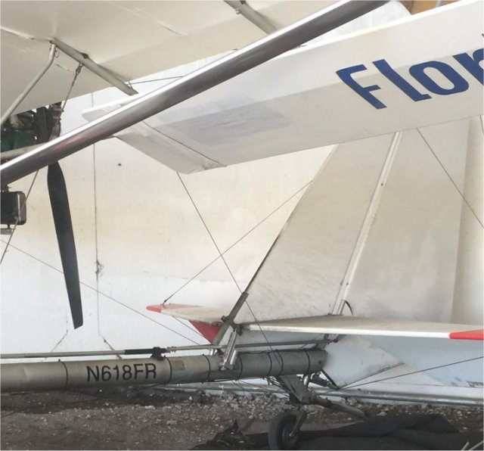
No 100 hour sign off.

Section: 2 AEROTOW PILOTS

MITCHELL NELSON SHIPLEY - 3514047
32560 LAKESHORE DR
TAVARES FL 32778-5004
County: LAKE
Country: USA
Medical
Medical Class: Second, Medical Date: 2/2016
MUST HAVE AVAILABLE GLASSES FOR NEAR VISION.
Certificates
PRIVATE PILOT
Date of Issue: 7/23/2013
Certificate: PRIVATE PILOT
Ratings:
PRIVATE PILOT
AIRPLANE SINGLE ENGINE LAND
WEIGHT-SHIFT-CONTROL LAND
Limits:
ENGLISH PROFICIENT.
NIGHT FLYING PROHIBITED WEIGHT-SHIFT-CONTROL LAND.

The logbook entries meet the requirements of FAR 61.69(a)(6).

JAMES EDWARD PRAHL – 3191513CFI
PO BOX 566
GROVELAND FL 34736-0566
County: LAKE
Country: USA
Medical
Medical Class: Third, Medical Date: 2/2015
MUST WEAR CORRECTIVE LENSES.
Certificates
PRIVATE PILOTFLIGHT INSTRUCTOR
Date of Issue: 9/25/2007
Certificate: PRIVATE PILOT Print
Ratings:
PRIVATE PILOT
AIRPLANE SINGLE ENGINE LAND

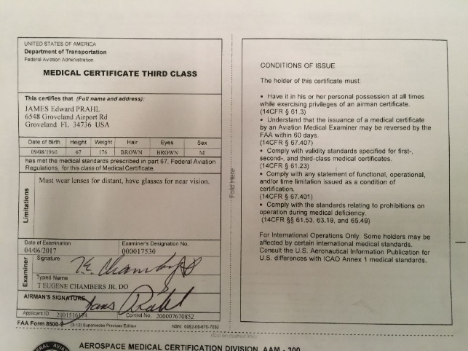

In lieu of documenting the requirements of FAR 61.69(a)(6) by making copies of log book entries, certification has been provided by a CFI as follows:
RUSSELL CRAIG BROWN
6217 DEWEY ROBBINS RD
HOWEY IN HLS FL 34737-4017
County: LAKE
Country: USA
Medical
Medical Class: Second, Medical Date: 5/2015
MUST WEAR CORRECTIVE LENSES.
Certificates
COMMERCIAL PILOTMECHANIC
Date of Issue: 7/13/2009
Certificate: COMMERCIAL PILOT
Ratings:
COMMERCIAL PILOT
ROTORCRAFT-HELICOPTER
GLIDER
PRIVATE PRIVILEGES
AIRPLANE SINGLE ENGINE LAND
Limits:
ENGLISH PROFICIENT.

In lieu of documenting the requirements of FAR 61.69(a)(6) by making copies of log book entries, certification has been provided by a CFI as follows:
JON COMBS THOMPSON
523 W WILKINSON ST
KILL DEVIL HILLS NC 27948-7781
County: DARE
Country: USA
Medical
Medical Class: Third, Medical Date: 5/2016
*** PLEASE CONTACT AAM-300 AT 405-954-4821 FOR MEDICAL INFORMATION ***
Certificates
PRIVATE PILOTFLIGHT INSTRUCTORGROUND INSTRUCTOR
Date of Issue: 11/1/2010
Certificate: PRIVATE PILOT
Ratings:
PRIVATE PILOT
AIRPLANE SINGLE ENGINE LAND
WEIGHT-SHIFT-CONTROL LAND
Limits:
ENGLISH PROFICIENT.
SPORT ENDORSEMENT(S) WEIGHT-SHIFT-CONTROL SEA.
NIGHT FLYING PROHIBITED WEIGHT-SHIFT-CONTROL LAND.

The logbook entries meet the requirements of FAR 61.69(a)(6)
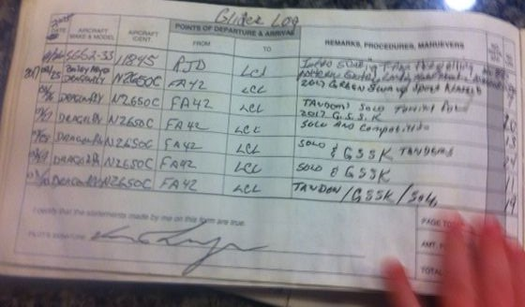
RHETT LANG RADFORD 3219770CFI
6548 GROVELAND AIRPORT RD
GROVELAND FL 34736-9685
County: LAKE
Country: USA
Medical
Medical Class: Third, Medical Date: 4/2015
MUST HAVE AVAILABLE GLASSES FOR NEAR VISION.
Certificates
PRIVATE PILOTFLIGHT INSTRUCTORREPAIRMAN LIGHT SPORT AIRCRAFT
Date of Issue: 11/1/2010
Certificate: PRIVATE PILOT Print
Ratings:
PRIVATE PILOT
AIRPLANE SINGLE ENGINE LAND
WEIGHT-SHIFT-CONTROL LAND
Limits:
ENGLISH PROFICIENT.
SPORT ENDORSEMENT(S) AIRPLANE SINGLE ENGINE SEA.
NIGHT FLYING PROHIBITED WEIGHT-SHIFT-CONTROL LAND.

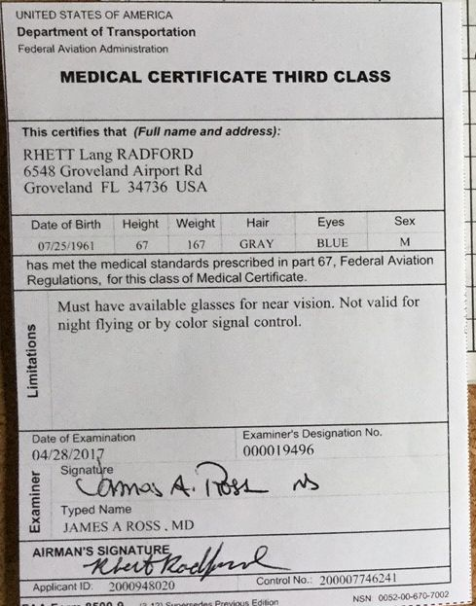

In lieu of documenting the requirements of FAR 61.69(a)(6) by making copies of log book entries, certification has been provided by a CFI as follows:

Section: 2 AEROTOW PILOTS
DERRECK KEITH TURNER
6861 CADET AVE
FORT MYERS FL 33905-7618
County: LEE
Country: USA
Medical
Medical Class: Second, Medical Date: 2/2016
Certificates
PRIVATE PILOT
Date of Issue: 3/20/2013
Certificate: PRIVATE PILOT
Ratings:
PRIVATE PILOT
AIRPLANE SINGLE ENGINE LAND
Limits:
ENGLISH PROFICIENT.

In lieu of documenting the requirements of FAR 61.69(a)(6) by making copies of log book entries, certification has been provided by a CFI as follows:

GREGG ALLEN LUDWIG
29435 FOX RIVER DR
SPRING TX 77386-2396
County: MONTGOMERY
Country: USA
Medical Information:
Medical Class: First Medical Date: 9/2017
MUST WEAR CORRECTIVE LENSES.
BasicMed Course Date: None BasicMed CMEC Date: None
Certificates
AIRLINE TRANSPORT PILOT |  | FLIGHT INSTRUCTOR |  | REMOTE PILOT |  | GROUND INSTRUCTOR
REPAIRMAN LIGHT SPORT AIRCRAFT

Certificates Description
Certificate: AIRLINE TRANSPORT PILOT
Date of Issue: 4/3/2014
Ratings:
AIRLINE TRANSPORT PILOT
AIRPLANE MULTIENGINE LAND
COMMERCIAL PRIVILEGES
AIRPLANE SINGLE ENGINE LAND
AIRPLANE SINGLE ENGINE SEA
PRIVATE PRIVILEGES
WEIGHT-SHIFT-CONTROL LAND
Type Ratings:
A/B-737 | A/B-757 | A/B-767 | A/B-777 | A/DC-9
A/L-188
Limits:
ENGLISH PROFICIENT.
SPORT ENDORSEMENT(S) WEIGHT-SHIFT-CONTROL SEA.
B-737 B-757 B-767 B-777 CIRC. APCH. - VMC ONLY.
Certificates Description
Certificate: FLIGHT INSTRUCTOR
Date of Issue: 5/2/2017
Ratings:
FLIGHT INSTRUCTOR
AIRPLANE SINGLE AND MULTIENGINE
INSTRUMENT AIRPLANE
Limits:
CFI SPORT ENDORSEMENT(S) WEIGHT-SHIFT-CONTROL.
VALID ONLY WHEN ACCOMPANIED BY PILOT CERTIFICATE NO. . EXPIRES: 30 JUN 2019.
Certificate: REMOTE PILOT
Date of Issue: 10/3/2016
Ratings:
SMALL UNMANNED AIRCRAFT SYSTEM
Certificate: REPAIRMAN LIGHT SPORT AIRCRAFT
Date of Issue: 5/17/2016
Limits:
MAINTENANCE: AIRPLANE, WEIGHT-SHIFT-CONTROL.
INSPECTION: WEIGHT-SHIFT-CONTROL, N447TX, SERIAL NO. 401.
WEIGHT-SHIFT-CONTROL, N5004D, SERIAL NO. MBP0308047.
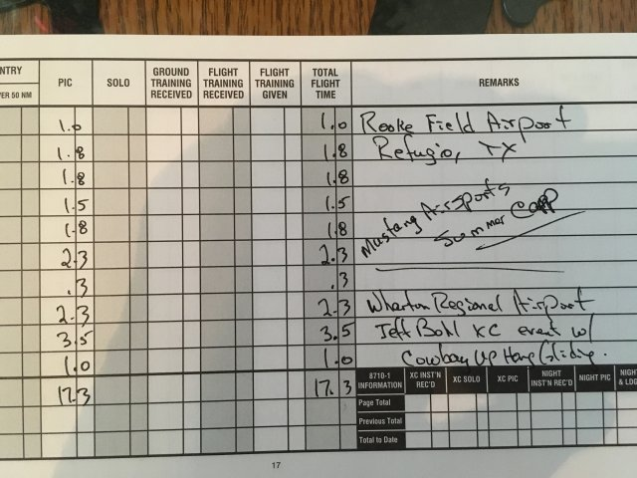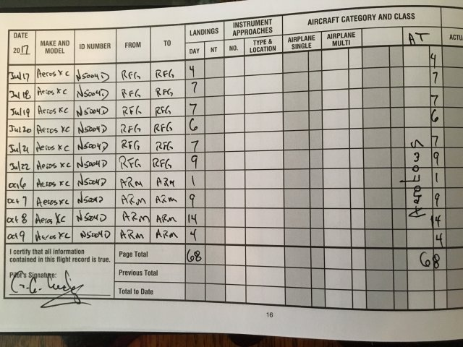
JOEL MICHAEL FROEHLICH
PO BOX 1131
MCQUEENEY TX 78123-1131
County: GUADALUPE
Country: USA
Medical Information:
Medical Class: Second Medical Date: 4/2017
BasicMed Course Date: None BasicMed CMEC Date: None
Certificates
COMMERCIAL PILOT |  | REPAIRMAN LIGHT SPORT AIRCRAFT

Certificates Description
Certificate: COMMERCIAL PILOT
Date of Issue: 2/27/2016
Ratings:
COMMERCIAL PILOT
AIRPLANE SINGLE ENGINE LAND
AIRPLANE MULTIENGINE LAND
Limits:
ENGLISH PROFICIENT.
THE CARRIAGE OF PASSENGERS FOR HIRE IN AIRPLANES ON CROSS-COUNTRY FLIGHTS IN EXCESS OF 50 NAUTICAL MILES OR AT NIGHT IS PROHIBITED.

ROBERT EUGENE BAILEY
6548 GROVELAND AIRPORT RD
GROVELAND FL 34736-9685
County: LAKE
Country: USA
Medical Information:
Medical Class: Third Medical Date: 5/2013
BasicMed Course Date: None BasicMed CMEC Date: None
Certificates
PRIVATE PILOT |  | FLIGHT INSTRUCTOR

Certificates Description
Certificate: PRIVATE PILOT
Date of Issue: 12/3/2010
Ratings:
PRIVATE PILOT
AIRPLANE SINGLE ENGINE LAND
Limits:
ENGLISH PROFICIENT.

EVGENIYA LARITSKAYA
NABEREZHNAYA NOVIKOVA-PRIBOYA12K3-40
123103 MOSCOW
Country: RUSSIA
Medical Information:
Medical Class: Third Medical Date: 2/2017
BasicMed Course Date: None BasicMed CMEC Date: None
Certificates
PRIVATE PILOT

Certificates Description
Certificate: PRIVATE PILOT
Date of Issue: 5/3/2017
Ratings:
PRIVATE PILOT
AIRPLANE SINGLE ENGINE LAND
Limits:
ENGLISH PROFICIENT.
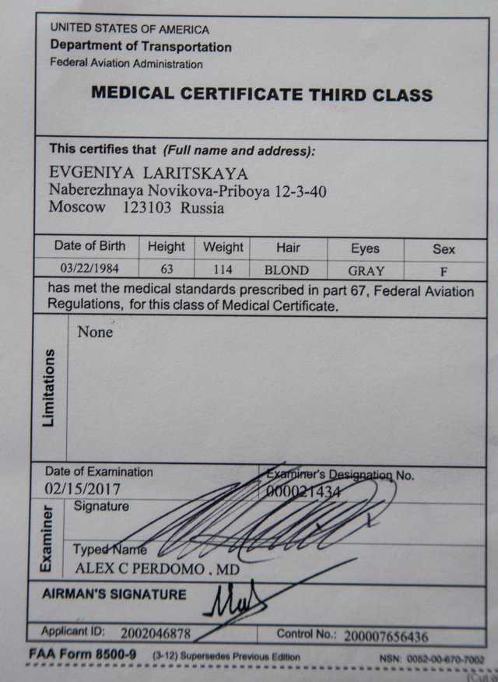
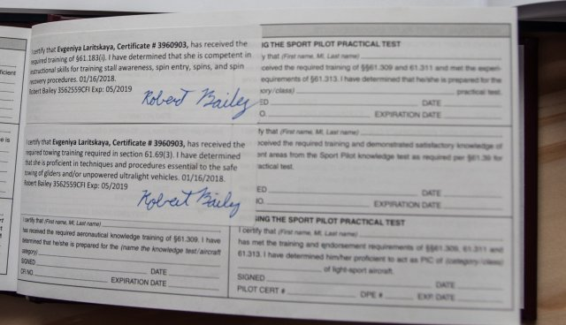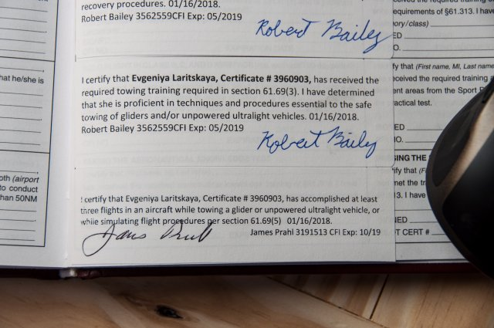
STEVEN WAYNE FLYNN
3300 SW 52ND AVE
BUSHNELL FL 33513-8255
County: SUMTER
Country: USA
Medical Information:
Medical Class: Third Medical Date: 5/2015
MUST HAVE AVAILABLE GLASSES FOR NEAR VISION.
NOT VALID FOR ANY CLASS AFTER. (CONTACT AAM-300 405-954-4821 FOR DATE)
BasicMed Course Date: 7/1/2017 BasicMed CMEC Date: 6/29/2017
Certificates
PRIVATE PILOT |  | REPAIRMAN EXPERIMENTAL AIRCRAFT BUILDER |  | REPAIRMAN EXPERIMENTAL AIRCRAFT BUILDER |  | REPAIRMAN LIGHT SPORT AIRCRAFT

Certificates Description
Certificate: PRIVATE PILOT
Date of Issue: 2/10/2010
Ratings:
PRIVATE PILOT
AIRPLANE SINGLE ENGINE LAND
Limits:
ENGLISH PROFICIENT.

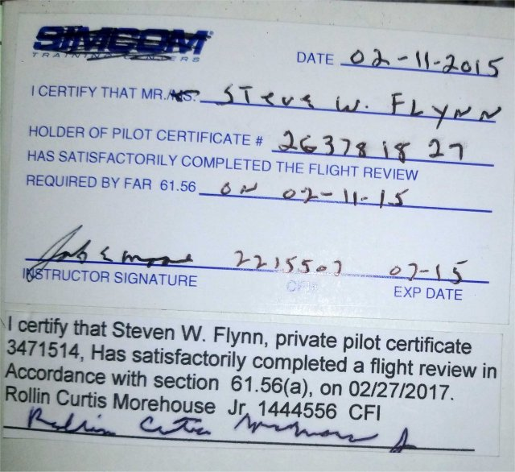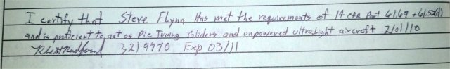

MICHAEL DEREK HOWARD
1331 COUNTY ROAD 192
LIVERPOOL TX 77577-7707
County: BRAZORIA
Country: USA
Medical Information:
Medical Class: Third Medical Date: 9/2016
BasicMed Course Date: None BasicMed CMEC Date: None
Certificates
PRIVATE PILOT |  | REPAIRMAN LIGHT SPORT AIRCRAFT

Certificates Description
Certificate: PRIVATE PILOT
Date of Issue: 4/22/2015
Ratings:
PRIVATE PILOT
AIRPLANE SINGLE ENGINE LAND
WEIGHT-SHIFT-CONTROL LAND
Limits:
ENGLISH PROFICIENT.
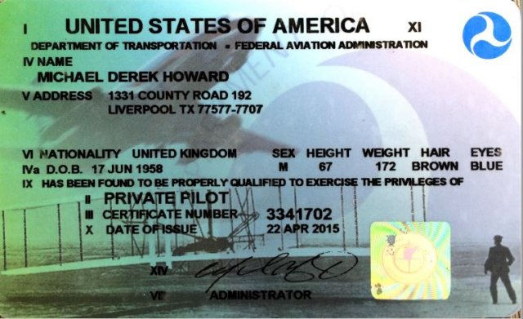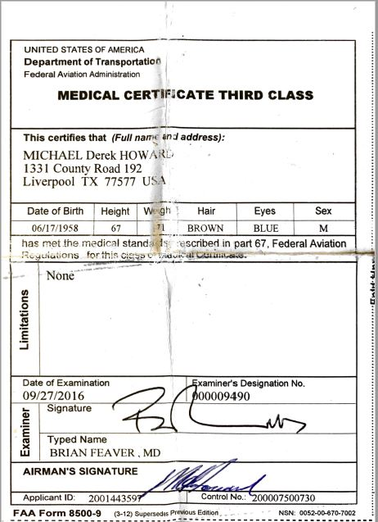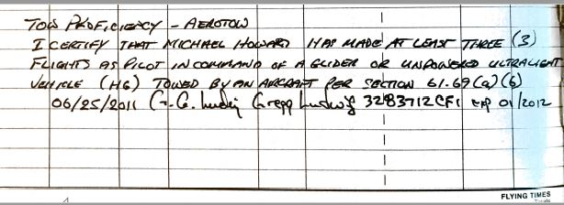

Aero-Tow Systems
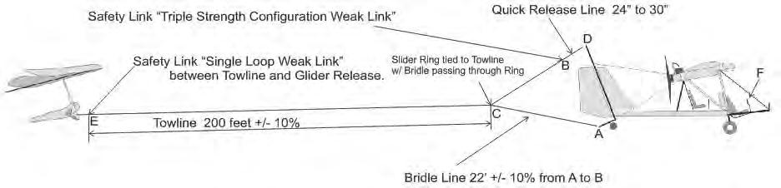

Section: 1.3
The tow bridle weak link consists of 130# Dacron braided green spot line (or equivalent) attached to the short end of the bridle at the top of the aft vertical stabilizer boom tube then looped through the two bridle ends so that there are three strands.
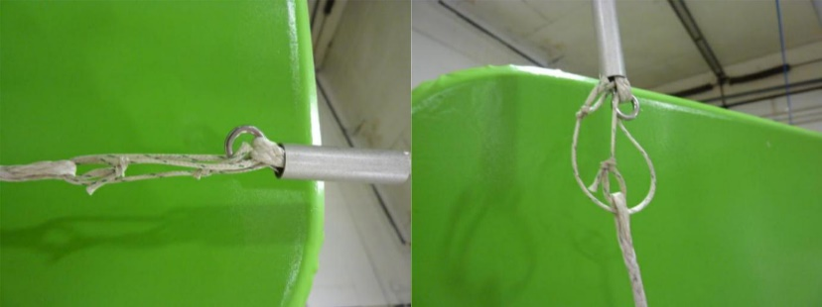
Dragonfly tow bridle weak link (typical)
Section: 1.4
The tow system uses a release similar to the “Schweizer” release that is activated by a release handle mounted on the stick.

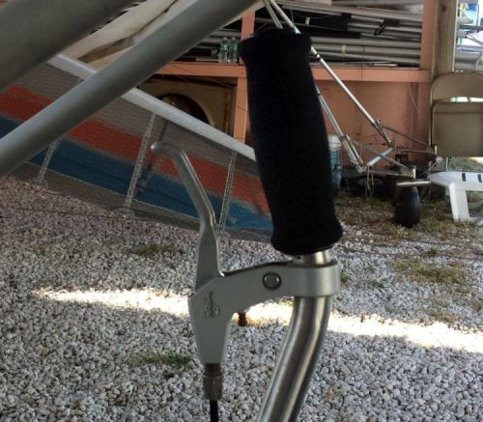
Tow line release handle (typical)
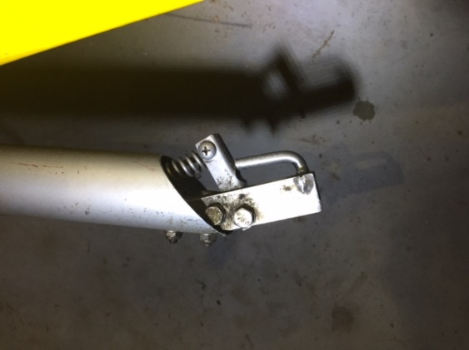
Dragonfly tail boom release (typical)
Section: 1.5
The tow bridle (Spectra or equivalent) attaches to the weak link near the top of the vertical stabilizer boom tube then runs through the tow line ring down to the release at the tail boom.

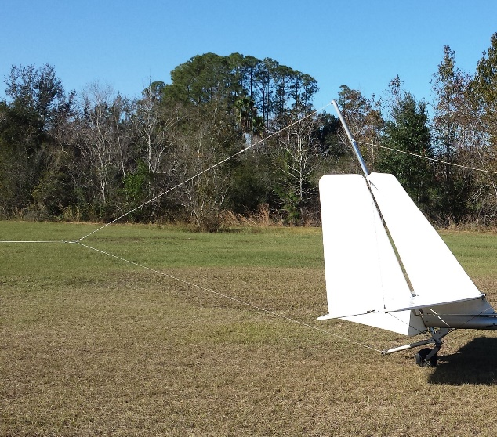
Dragonfly Tail Bridle (typical)
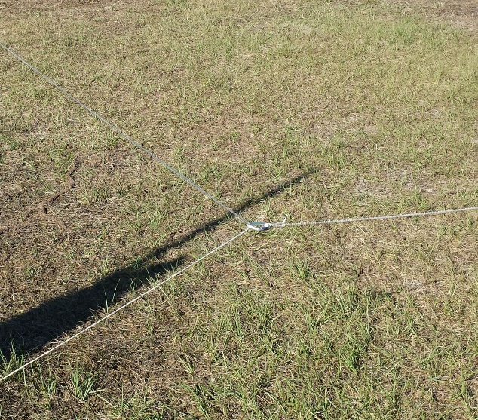
Dragonfly bridle slider ring (typical)

Section: 1.8
The towlines are 200’ +/- 10% Spectra 1200# or equivalent.

Section: 1.6 Dragonfly Checklist

Preflight Check (The same type of inspection should be done as Post Flight Inspection)

Every time the plane is prepared for flight the entire aircraft must be subjected to a pre-flight check whereby the pilot visually checks the aircraft to ensure that the aircraft is in a condition for “Safe Operation”.

Conduct the pre-flight check as a walk around the aircraft starting at the same point each time, to ensure that every part of the structures, cables, attachments and components are inspected. Every part or component must be free of excessive wear, defect, tears, cracks, Loose or missing bolts, hardware etc. etc. refer to Figure 4 Pre-Flight Areas.

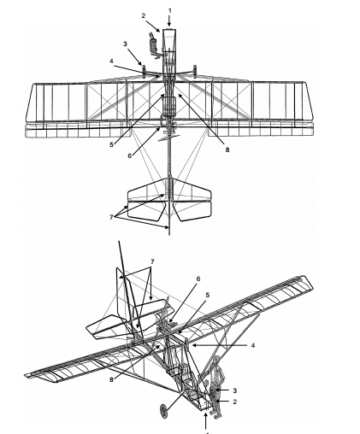

  - Aircraft and engine controls

For each seat check that the rudder pedals and stick move freely into all extreme positions. Check the links and connections on the stick and rudder to ensure that they are connected correctly and secured.

Check the condition of the seats and check that the seatbelts are securely fastened. Check that the fuel tank is securely fastened and with the cap screwed tight and containing the sufficient amount of fuel for the intended flight time.

  - Instruments

Check the Pitot Tube orifice is clear of obstructions. (A simple test can be done to check that airspeed indicator works by blowing from several inches away, across the Pitot Tube, NEVER BLOW DIRECTLY INTO THE PITOT TUBE as this can permanently damage the ASI & ALT instrumenst. Ensure that the indicator returns to zero position.)

Check the correct indicating positions of the other instruments also.

  - Undercarriage and main wheels

Check (visually and by hand) that the tires have the correct air pressure. Check that the tires are free of any damage. Check that the wheel nuts are in place and not loose, and that the undercarriage legs/axles are securely fastened to the fuselage.

  - Emergency parachute

Check that the emergency parachute is securely fastened to the aircraft with the cover sitting in the correct position and with the bridle secured around the main root tube. Remove the safety pin from the release handle and stow in a secure position. Re Insert the safety pin in Post Flight Inspection. Minimum Pressure 4200 psi

  - Left part of the wing

Remove the inspection panel behind the parachute and inspect the inside of each side of the wing ensuring that all battens are in place and that all tubing and support cables are undamaged. Replace the inspection panel and secure using the Velcro strips. Check that the Dacron wing surface is free of holes or other damage. Check that each end of the strut and outside support cables are securely fastened on the fuselage, tail and wing respectively.

Check that the aileron is securely fastened to the wing and that it moves freely between the extreme positions. Check that the linkages and connections to the control surface are securely fastened.

  - Engine and propeller (Left Side)

Check that the propeller is free of damage, especially delamination of the composite material. Check that the engine and muffler is securely fastened to the engine assembly plate and that this is securely fastened to the aircraft. Ensure that all safety wires are in place as required on the propeller, gearbox and engine bolts. Check that the oil tank and the radiator are filled to proper level (overflow bottle should have fluid at minimum mark cold) and check that the ignition cables are securely in place on the spark plugs. Insure Propeller bolts are secure, and inspect prop for damage.

  - Tail

Check that the rudder and elevator moves freely between the extreme positions.
Check that the linkage and connections for the control surfaces are securely fastened. Check (visually) that the tail wheel tire has the correct air pressure and is free of damage. Check that the wires from the rudder pedals are connected correctly to the steering plate. And that supporting cables are free of defect or wear.

Repeat 1.6 Engine and propeller for Right Side of Engine

  - Right part of the wing. Same as for the inspection of the left wing. 1.5 above

Inspect each side of the wing ensuring that all battens are in place and that all tubing and support cables are undamaged. . Check that the Dacron wing surface is free of holes or other damage. Check that each end of the strut and outside support cables are securely fastened on the fuselage, tail and wing respectively.

Check that the aileron is securely fastened to the wing and that it moves freely between the extreme positions. Check that the linkages and connections to the control surface are securely fastened.

2 Engine starting

WARNING: Do Not attempt Hand starting by turning the propeller, it is Very Dangerous. Always use the electric start system.

FUEL: Approved types of fuel, 90+ octane quality unleaded auto gasoline (10% ethanol is approved) ( No Methanol Content) . * (use of 100 LL may require additional provisions listed in current Rotax manuals)
* refer to Rotax Operators Manual or www.flyrotax.com for current recommendations.
OIL: 582 Approved* types and brands of TCW-III mixed 50:1

- Approved* types and brands listed in the Current Rotax 912 manuals

  - refer to Rotax Operators Manual or www.flyrotax.com for current recommendations.

STARTING THE ENGINE;

- Ensure rear seat belt is fastened so that it will not fly into prop and no other item is loose that will be drawn into the propeller stream.
- Pump fuel to the carburetors by operating the squeeze bulb in the fuel line till the bulb is firm.
- Ensure that the throttle is in Idle Position (Closed)

- Choke on (Cold Start)
- Check that prop is clear of bystanders.

(When you are ready, look both sides and call loudly “CLEAR PROP”)

- Ensure that the front of the aircraft is clear.
- Operate brakes. (On)
- 582 Pump bulb until it beomes hard. Pump primer 2-3 times.
912 Equipped with Electric Boost Pump, run pump until fuel is seen returning to tank through the return line.

- Call “CLEAR PROP” to warn observers, & look to insure it is clear.

- Turn IGNITION Switches ON and Press Starter Switch to Start.

Normally the engine will start within 2 seconds. Do not crank the engine more than 10 seconds if it does not start. Longer operation may overheat the starter motor.

( 582 only -- Cold conditions require more priming. Pump primer twice more and try again.)
The behavior of the engine will indicate the problem. In most cases it is too much or too little fuel to suit the temperature.

Should the engine not start after three or four attempts then it is possible that the engine is flooded with fuel. To balance this situation, open the throttle to allow more air to be drawn in.

CAUTION: With the throttle open the aircraft may surge forward when it starts. Be ready to Close Throttle.

Operate the starter with one hand on the throttle to immediately pull the throttle back to idle or low power if the engine starts and be ready to SWITCH OFF if an emergency arises.

When the engine starts allow it to idle at 2000 – 2200 rpm for a full minute or longer to allow the engine to reach operating temperature. Let the engine warm up properly before applying too much power!
582 Coolant to 140 degrees F, before exceeding 3000 rpm’s.
912 Oil Temperatures to 120 degrees F, before exceeding 3000 rpm’s.

IMPORTANT NOTE: A thorough warm up is essential to the longevity to the engine life and performance.

4.3 Taxiing

The Rudder pedals operate rudder and tail wheel steering. Control is easy and turning radius is average. Taxiing in cross wind up to 15 mph creates no problem.

Both the rudder and tail wheel turn the aircraft in the same direction.

For a left turn PUSH LEFT PEDAL
For right turn PUSH RIGHT PEDAL

At times Low Speed Taxiing can be improved by pulling up elevator to hold the rear wheel firmly on the ground. When taxiing down wind keep the stick in Neutral Position.

When attempting to taxy across wind lean the stick into the wind to reduce lift on the upwind flaperon. Failure to keep the aircraft balanced can lead to Ground Loops.

Section: 3 Launch Equipment
Section: 3.1 Hang Glider Pilot Aerotow Checklist
- Check that the glider has been pre-flighted.
- Check cart integrity; adequate air pressure in tires, keel support at proper height, glider hold down mechanism adjusted properly and wheels are straight.
- Check that glider is properly seated in cart saddles with wheels on the outside (if applicable) and keel is centered on the support.
- Perform a hang check.
  - Check that harness is connected to the glider main and backup hang loops and the carabiner is locked. If using a direct connect harness, check that harness is hooked in to direct connect system inside the sail.
  - Check proper height above bar.
  - Check that harness lines are straight, leg loops are connected, chest buckle is connected and parachute pins are in place.
  - Check that lines are fully retracted especially pod harness line at the harness boot.
  - Check that helmet is buckled.
- Check that the bridle is free of all restrictions and is routed above the basetube.
  - Check bridle connection to release closure mechanism.
  - Check bridle line for knots.
  - Check weak link(s) and replace if necessary.
- Check glider VG line is set for anticipated tow speed and desired bar pressure and is properly stowed.
- Check instruments are properly attached to base/downtubes and turned on.
- Check that radio is on and working properly.
- Connect tow rope to bridle. Check tow rope clip for proper closure.
- Signal for "take up slack”.
- Check final line tight configuration of release, bridle, tow rope and clip for routing, knots and assembly/closure.
- Check tow rope is clear and no knots are visible.
- Check that wind conditions are suitable for launch.
- Check for air traffic.
- Mentally prepare for tow and emergency actions.
- Say "Go go go!" to start the launch.
REMEMBER, as the pilot of a Hang Glider, YOU are responsible for checking everything! A crew person is only an assistant, and a second pair of eyes. Attention to detail is paramount. Should there be any problem that you did not catch, you must take responsibility for your own safety! Releasing is the only way to abort a tow!

Pilot Checklist -- Short version:
- Glider pre-flight complete
- Cart pre-flight complete
  - Wheels straight, tires pressurized and rotating freely
  - Saddles centered and hold down hose tight
  - Keel support adjusted properly
- Glider seated on saddles and keel support
- Harness Check complete
  - Main and backup loops connected
  - Leg loops connected
  - Chest buckles connected
  - Parachute pins in place
  - Harness lines straight and retracted (check boot)
- Bridle and weak link(s) check complete
- Instrument, radio checks complete
- VG cord set
- Tow line connection check complete
- Tow “line tight” checks complete
- Launch conditions check complete

Section: 3.2
Tow Launch Cart description and pictures – A three wheeled cart or dolly is used to tow the hang glider to the proper airspeed prior to leaving the ground. The dolly has two wheels in the front and one wheel in the rear. The wheels are pressurized with air. The two front wheels are castered to provide lateral control during the initial roll-off. There are two saddles mounted on two front supports between the front wheels that slide laterally to accommodate for different size glider base bars. The saddles have individual hoses attached to allow the pilot to hold the glider to the cart during the initial tow until proper airspeed is reached. An adjustable vertical support is located in front of the rear wheel to cradle the keel of the glider and hold it at the proper angle of attack during the initial tow. This support can be adjusted to different heights based on the glider configuration and is held in place by pins.

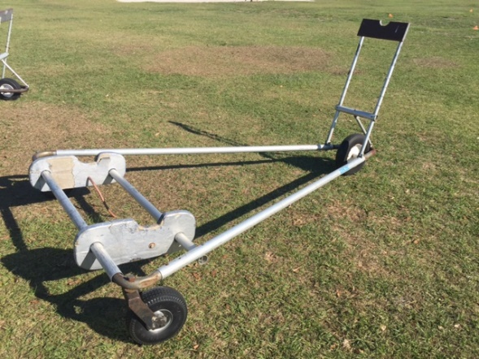
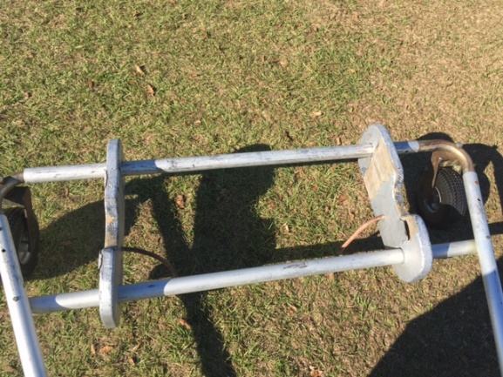

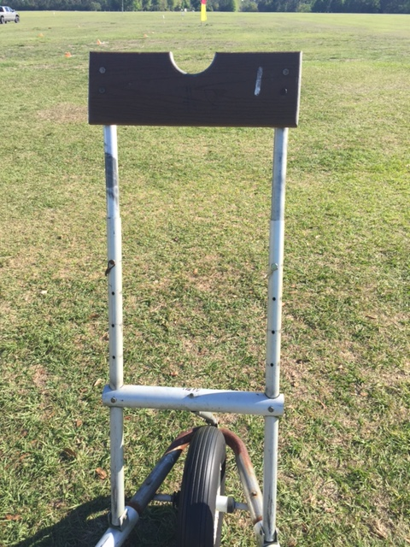
Tow Cart (typical)

Section: 4 Hang Gliding Equipment
The integrity and acceptability of the hang glider, harness, tow bridle mechanism and attachment, wheels, and accessory equipment such as instrumentation and cameras are the sole responsibility of the pilot in command. The pilot is responsible for conducting pre-flight checks of any and all of their equipment prior to flight. Launch crew personnel will be performing back up checks however are not to be relied on for the safety of the pilot.
Section: 4.1
Wheels may be used at the discretion of the pilots and are solely responsible for performing a pre-flight check to verify proper condition and operation.
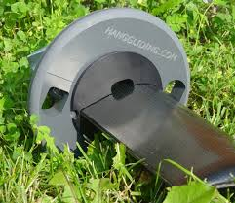
Base tube wheel system (typical)
Section: 4.2,3,4
Tow Bridle/Release Mechanism/Attachment point - Competition pilots choice and safety officer approved with typical acceptable releases being barrel release two point pro-tow and three point tow with bicycle handle on downtube or in hand loop release.
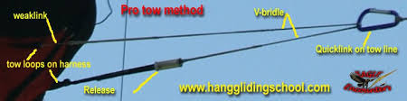

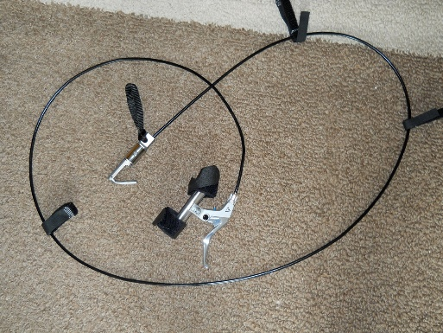
Bicycle Handle Release (typical)
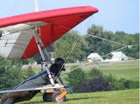
Three Point Bridle (typical)
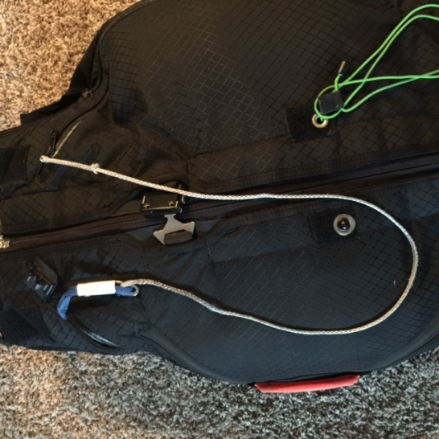
Harness Attachment Points (typical)
Hang Glider Weak Link – Single loop braided Dacron 130# or 200# test (such as Magibraid, Tuf Line or equivalent).

Section: 5 Aerotow Procedures
No Training Syllabus will be used as part of towing
operations as this event is a race to goal competition where no training activities will be taking place.

Section: 6 Video of Aerotow Operations
Section: 6.1
No tandem launches will be conducted as part of this competition.
Section: 6.2
Here is a typical solo hang glider launch: https://www.youtube.com/watch?v=9nzX_48gxkc

