Pilot Briefing Content
The obstacles at Wilotree field are displayed in the accompanying satellite photo.
There are at least six wind indicators along the runways.
The designated relaunch landing area is north of the east/west runway and east of the north/south runway, south of the RV Park, west of the lake. Pilots are required to land in the designated landing area if they land back at Quest while aerotowing is still on-going. The designated landing area is shown on the accompanying photo.
Pilots will be given the approach direction each day depending on the wind direction and the launch area. When landing to the north with tugs landing near the south east field, pilots need to approach the designated landing area from the south but high enough to avoid conflict with tugs landing from the south in the southeast field. In this case Pilots should not go back further than the east/west runway for their base leg.
When landing to the south pilots should approach from the east side of the runway south of Groveland Airport Road. When approaching from the east, come in over the lake. When approaching from the west, come in over the trees on the north side of the east/west runway.
Launch procedures:
Launch crew will keep spectators 50 feet away
Pilots are required to be at the staging areas a half hour before launch opens.
Pilots are to preflight their gliders before being attached to them and before getting into the launch line.
Weaklinks will be available from the launch director or his/her assistants.
There will be two launch lines and two accompanying staging lines. You set your glider in the staging line according to your launch order number for the day.
Pilots are to ensure that the back cradle of the cart is adjusted for the proper angle before getting into the cart. Pilots may test for the proper angle while in the cart and then lift their glider to have it adjusted by the launch crew, well before their time to launch.
The launch crew and the pilot are to check each cart to make sure that they are in operating condition before getting on the cart.
The first five pilots are required to be in the launch line five minutes before the launch opens.
Pilots will be checked in the launch line by the launch crew. However they must be completely ready to launch by the time they get to the launch box. This means all distractions must be eliminated by the time the pilot is ready to launch.
There will be an open launch (“early bird”) window of 15 minutes for open class pilots.
The rigid wing pilots will launch first followed by the open launch window.
There is an implied push rule for launch. Pilots who do not wish to launch in their order will go to the back of the staging line.
You must hold onto the hoses and keep the cart with you until you are ready to come off it
If you have wheels (like the Wills Wing forward projecting wheels) make sure that they can’t get jammed into the cart if you come off crooked.
Wind direction and velocity determine the launch area and launch direction. South-southeast wind speeds up to 15 - 20 mph can be accommodated from the north-northwest launch area. Westerly winds up to 10 - 15 mph can be accommodated from the east and southeast launch. East winds up to 10 – 15 mph can be accommodated out of the west launch. Northerly winds 10 – 15 mph can be accommodated out of the south launch.
Variations in wind direction and gust factors below 5 mph will be evaluated to determine launch safety. Gusting over 10 mph will keep the launch suspended or closed.
Pilots breaking a weaklink (let off below 1,000’) will be shuffled into the launch order by the launch crew. Otherwise pilots who land will go to the back of the staging line and enter the launch line after the last of the pilots launching for the first time.
There will be a maximum 15-minute relaunch window for open class pilots (only those in the launch line) after all the open class pilots have launched once, to allow for relaunches .Then after the maximum of 15 minutes has elapsed, the sport class launch will open and other open class pilots must launch behind them. This may be adjusted if many pilots are not sticking.
Towing operations protocol at Wilotree Park is for the launch directors to check for tugs or hang gliders in the air above launch prior to launching each glider. It is up to the tow plane and hang glider pilots to check for traffic in the event they are landing back at Wilotree Park and take the necessary actions to put their aircraft down safely
There will be a first aid kit at the launch area. The meet director and her assistants will determine the need for additional medical interventions. They will be the only ones to call 911 if it is an emergency.
Emergency personnel are within 2 miles, will be notified in advance of this event, and can be called by 911. The meet has a current Red Cross First Aid certificate. Any other first aid experienced personnel will be identified.
Pilots must comply with all requests from the meet personnel.
Incidents we wish to avoid:
Tree landings. These can happen (although they are extremely rare) if you are flying a lower performance glider on a windy day and you get downwind of the field. Try to land in a downwind or side wind field if you are too low.
Outrunning the runways: Start your final with plenty of room for gliding down the runways or designated landing area. Don’t go down the runways too far to get in any rotor caused by wind in the trees.
Be prepared on launch: Fly the glider off the cart and do not try to make any adjustments to your instruments and gear until you are off tow. Always continue to fly the glider.
Unidentified risks and obstacles: The team personnel will identify any safety issues that come up during the competition and relay those to the pilots during the meet.
Getting stuck in the cart: If you have wheels make sure that they can come free of the cart if you are lifted off the cart. If you have wheels that extend down from the basetube, use a cart that has cradles that are set high above the cart tubes. There is one cart with cradles 3” above the cart tubes.
Additional information about this can be found in the Oz Report: http://ozreport.com/22.064#1, http://ozreport.com/22.066#3, and http://ozreport.com/22.067#2.
Improper cart launch control technique: If your glider rises up to one side or the other while you are on the cart, shift your whole body to the side of the lifting wing, not just your shoulders and head. Pivot around a point about three feet in front of the center of your base tube getting your legs and feet to the side of the rising wing. Before your start make sure that the cart’s cradles are as far to the left and right as possible and hold on tight to the hoses. Cross controlling does not work.
Launch order:
We have two options in the local rules. Launch by arbitrarily selected rotating group or by WPRS and then cumulative points. We will decide before the first task which method to use.
Scoring:
On the first day there will be no leading or arrival points. To account for glitches in the aerotow operation. After that scoring will be default hang gliding GAP 2016 as implemented in FS using arrival time points.
Task Briefing:
There will be a task briefing each morning at the pilot briefing. The task briefing will include a description of the goal and any obstacles or hazards that may be found there including obstacles on the course line coming into goal, but not at goal. If the goal is an airfield, we will present information about the airfield from http://airnav.com.
If the technology works, we will display the task on a large TV screen and show the satellite photos of the goal and other areas along the task.
Tie downs:
Wilotree park provides anchors and tie down cables for securing hang gliders. We have an insufficient number of tie down ropes for 120 pilots. Please bring your own tie down straps to allow you to secure your glider to the cable or anchors.
Bring your own anchors and straps to tie down your glider in the staging line if unattended.
Highway 33, parking and drop off:
The parking area is on the north east side of Groveland Airport Road. It is marked by logs parallel to the road. You park perpendicular to the logs coming from either the north or south. Please stay east of the road sign marked Low Flying Aircraft. Also, do not block access to the dumpster especially on Tuesday.
The drop-off area is to the right, south of Groveland Airport Road toward the club house. Please unload your equipment there and then move your vehicle to the parking area
The intersection at Highway 33 and Groveland Airport Road is a very dangerous intersection. We see plenty of accidents there. The highway speed is 60 mph. Signal your intent to turn 1000 feet away from the intersection. Tap your brakes to indicate that you will be slowing down. If the semi-truck behind you is not slowing down, you may wish to continue on and turn around at the next opportunity.
Slow down and turn sharply onto Groveland Airport Road as there are ditches on both sides.
Landing Out:
The area around Wilotree Park and central Florida in general has many wide open pasture areas that make for great landing fields. Power lines are obvious, swamps (wet areas with trees) are obvious, the wind direction is obvious, fences in pastures are pretty obvious, horse pastures are pretty obvious (brown wooden fences), housing developments are obvious, golf courses are obvious. There is little to no need to force yourself into a small landing area or dangerous situation.
Be sure to get plenty high before crossing areas with restricted landing possibilities. Watch for small power poles in open fields. Watch for fence lines.
Do not have your driver drive into a field unless you have permission from the land owner. Stay outside the fences, even if there is no lock on the gate.
Weather conditions:
There will be a weather briefing each morning at the pilot briefing. It will include the forecasted average lift, TOL, cloud base, winds on the ground and aloft, chances of rain and/or thunderstorms, temperature at cloud base or top of lift, changes over the afternoon in these values.
The normal April conditions are for moderate to strong lift, light winds, 5,000’ to 7,000’ TOL, cu’s, surface temperatures in the 80’s. Little chance of thunderstorms.
Weather links: http://ozreport.com/seweather.php
https://airtribune-production.s3.amazonaws.com/media/contest/files/2018/03/vT9A5TJS8mJM.pdf
https://radar.weather.gov/radar.php?rid=tbw&product=N0R&overlay=11101111&loop=no
https://forecast.weather.gov/MapClick.php?lat=28.5593&lon=-81.8553&unit=0&lg=english&FcstType=graphical
http://www.intellicast.com/National/Surface/Mixed.aspx?enlarge=true
https://rucsoundings.noaa.gov/gwt/?data_source=Op40&latest=latest&start_year=2017&start_month_name=Mar&start_mday=10&start_hour=4&start_min=0&n_hrs=18&fcst_len=shortest&airport=28.53,-81.85&gwt=Interactive%20plot&hydrometeors=false&start=latest
https://www.xcskies.com/map
Safety on the course line:
The meet director and the Safety Director will monitor conditions using local radar in the task area for thunderstorms. If thunderstorm activity is nearby the meet director will contact the safety committee through their drivers and ask for reports from the pilots. 1 = safe, 2 = watching conditions, 3 = unsafe, time to stop the task.
Pilots will be contacted through their drivers if the task is stopped.
Flymaster Trackers:
Obtain your Flymaster tracker from Tony Mercado at the pilot briefing or just after it.
Half an hour before launching press the upper right-hand button and then the upper left -hand button on the Flymaster Tracker before the red flashing timer times out (do this procedure again if it times out). This starts the tracking.
Place the tracker in your harness (or glider) where it has a good view of the satellites.
As soon as you land, first thing, again press the upper right-hand button and then the upper left -hand button on the Flymaster Tracker before the red flashing timer times out (do this procedure again if it times out). The Tracker will not turn off, that is by design. Three red LED’s, will flash, which means that it is in competition mode and is ready to be charged.
This procedure tells the meet director that you are okay and have checked in.
Bring the Flymaster Tracker to Tony Mercado in the evening as soon as you return from your flight. He will charge it for the next day.
If you land and need medical assistance, press and hold the SOS button for ten seconds. Also if you don’t check in (see above) we will call your driver to see if you are okay. They should have your location from Live Tracking on Airtribune.
You do not have to send in your track log as it is automatically sent to the Flymaster server which the scorekeeper accesses.
Sending in your track log if the Flymaster tracker wasn’t turned on:
If there was some glitch with your Flymaster Trackers you can upload your tracklog from your flight instrument to the scorekeeper. Send the IGC file to hangglidingcompetition@gmail.com. The scores will be up quite early on line (around 7 – 8 PM) so check them to be sure they are correct for your flight. If not send up your track log.
If you were absent or did not fly send an email to hangglidingcompetition@gmail.com informing the scorekeeper of that fact.
Notices from the Meet Director:
The meet director will send notices, SMS text messages, to your cell phone. You activate receiving these messages by sending a SMS text message to 40404. The message is: FOLLOW @QANS2018
Jonny Durand has also set up a What’s App group for the competition at : https://chat.whatsapp.com/0jePaJNw6MQDiWYBkTQbp6
Pilot Responsibilities and Local Rules:
Both of these documents can be downloaded from here: https://airtribune.com/2018-quest-air-national-series/info/details__info. There will be hard copies posted in the pilot briefing area
Other Documents:
The complete Risk Management Plan is available on-line at RMP on-line at https://airtribune.com/2018-quest-air-national-series/info/details__info.
Additional documents including all the rules, local. national and international can be found here: https://airtribune.com/2018-quest-air-national-series/info/details__info.

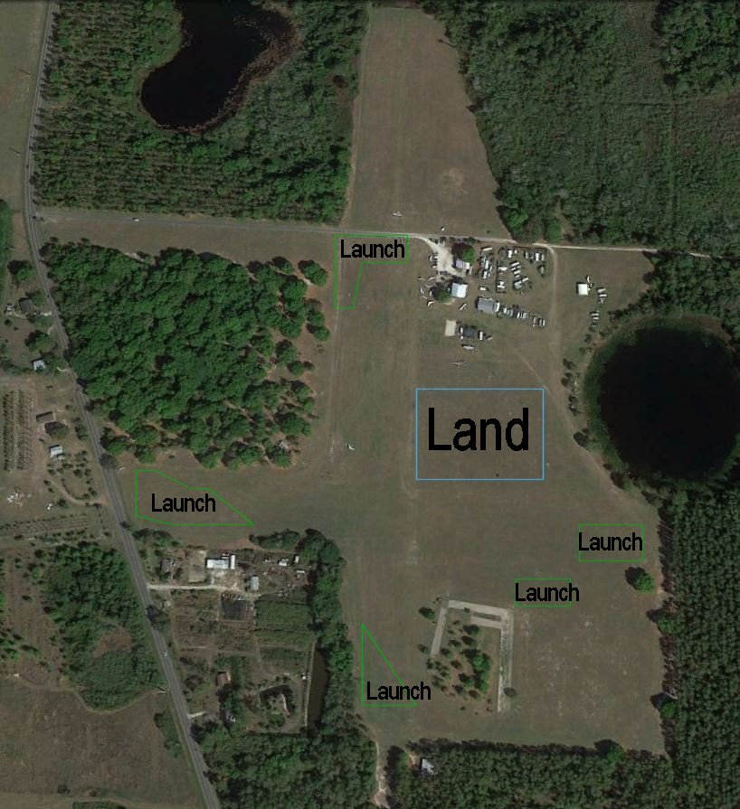
Launching - green
Designated Landing – light blue
The designated landing area is the area east of the runway when launching from the north end or on the south half of the runway.
The designated landing area is the area to the east of the runway when launching from the south end or at the north half of the runway.
The designated landing area is the area to the north of the runway when launching from the west end.

