

Local Regulations
TUPIŽNICA OPEN 2018
Tupižnica, Serbia, 25th – 27th May 2018
PARAGLIDING CROSS COUNTRY
FAI category 2 event
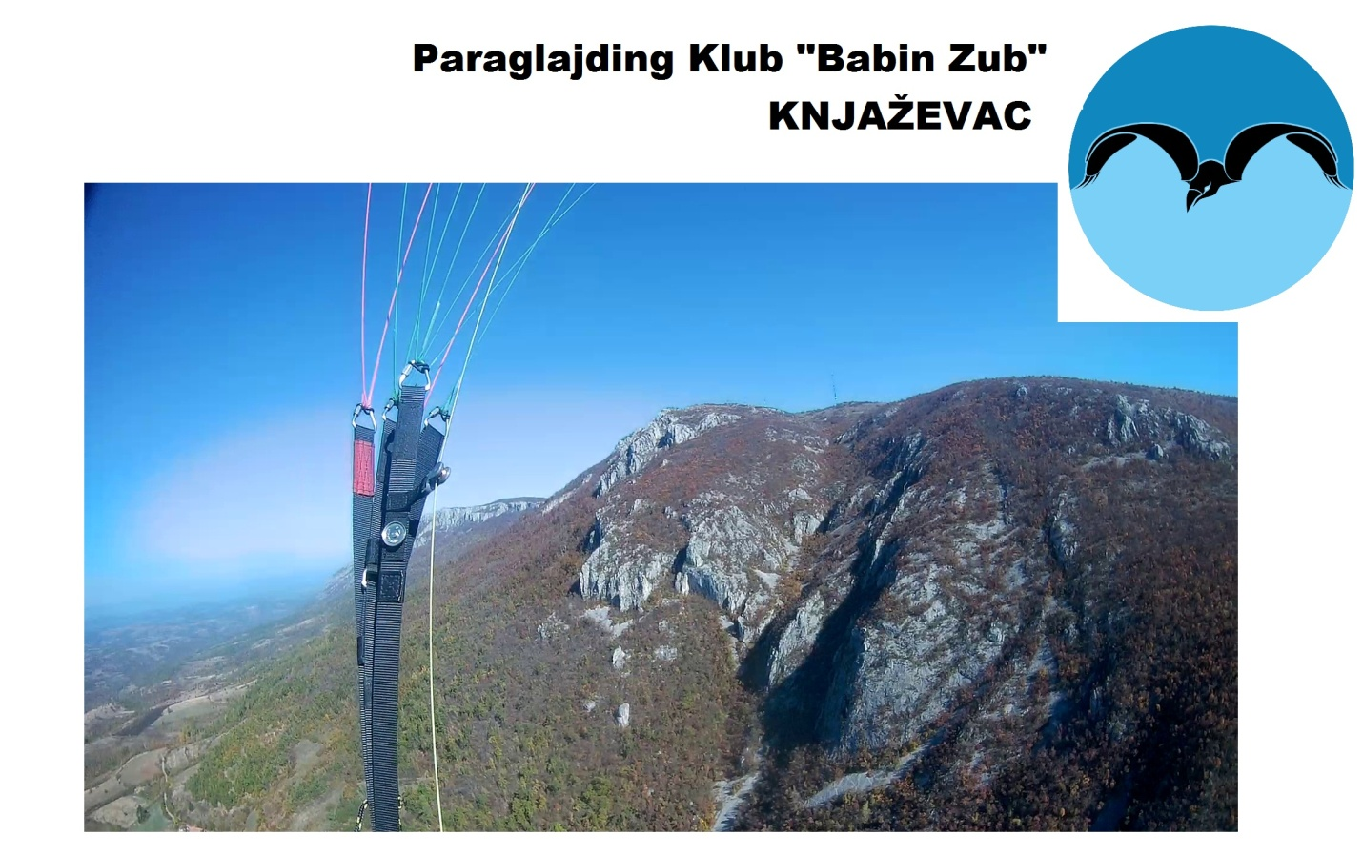
These local regulations are to be used in conjunction with General Section and Section 7B of the FAI Sporting Code. Reference numbers for Section 7B used in this text should be crosschecked with the latest edition of Section 7B.

1 – CONTACT

PgK “Babin Zub”, Knjaza Miloša 41, 19350 Knjaževac
Marko Prvulović: marrkkoprvulovic@gmail.com, +381643538612
- HQ: Dom ucenika srednjih skola Knjazevac, Kaplarova 10, 19350 KNJAZEVAC

2 – PROGRAM AND DAILY SCHEDULE

Thursday 24.05.2018
19.00-21.00 | Registration and accommodation

Friday 25.05.2018
07.00-09.00 | Registration and accommodation
09.00 | Opening ceremony and mandatory safety meeting
09.30 | Transport to take-off
11.00 | Task & safety committee
11.30 | Briefing
12.00 | Window open
17.00 | HQ opening
19.00 | Safety landing report deadline
21.00 | Provisional results and complaints deadline
22.00 | HQ closing

Saturday 26.05.2018
08.00 | HQ opens
09.00 | Briefing
09.30 | Transport to take-off
11.00 | Task & safety committee
11.30 | Briefing
12.00 | Window open
17.00 | HQ opening
19.00 | Safety landing report deadline
21.00 | Provisional results and complaints deadline
22.00 | HQ closing

Sunday 27.05.2018
07.00 | HQ opening
09.00 | Complaints deadline
09.30 | Transport to take-off
11.00 | Task & safety committee
11.30 | Briefing
12.00 | Window open
16.00 | HQ opening
18.00 | Safety landing report deadline
18.30 | Results and complaints deadline
19.00 | Prize-giving and closing ceremony

*This schedule is subject to change by the Meet Director.
** Reserve date is next weekend, 1-3 Jun.

3 – OFFICIALS AND STAFF

- General Organization: PgK “Babin ZuB” Knjaževac
- Meet Director: Marko Prvulović
- Safety Director: Robert Milosavljevic
- Take-Off Marshall: Ivan Kostadinović
- Transport and Retrieval: Aleksandar Ristić
- Goal Marshall & Scorer: Srđan Stanojević
- HQ coordinator: Aleksandra Milosavljević

4 – FLYING SITES

Tupiznica (Ambicija) (NW, W, SW)
Take off: Ambicija at 1160 m, GPS: N 43.70, E 22.15
Landing: Bucje at 530 m, GPS: N 43.68, E 22.13

Tupiznica (South) (SW, S, SE)
Take off: South at 1100 m, GPS: N 43.69, E 22.14
Landing: Bucje at 530 m, GPS: N 43.68, E 22.13

Tupiznica (East) (SE, E, NE)
Take off: East at 1100 m, GPS: N 43.69, E 22.16
Landing: Kozelj at 390 m, GPS: N 43.68, E 22.19

* Others appropriate sites may be used by the Meet Director, after consultation with the Task committee.

5 – ENTRY FORMS AND REGISTRATIONS

The Championship is open to all pilots from countries that are members or associated members of FAI. The FAI license is mandatory to join a Tupižnica Open 2018 event. For the Serbian pilots will be provided 25. Deadline for this places is 1st May, after that date all places, up to 50th place , are open for all pilots worldwide. Entry Forms will be filled during the registration.

6 – SELECTION PROCEDURES

Team have 6 members (4 + 2 junior or female). Team score for each task will be assembled from best 2 results (any gender).
The requirements for a pilot to enter this competition are:
• to hold valid FAI and pilot license.
• to prove the airworthy of his glider.
• maximum number of participants is 50.

7 – ENTRY FEE

Entry fees:
- Before 1st May – 50 eur
- After 1st May – 60 eur
- After 18th May – 70 eur

Please make payment to: Paraglajding Klub “Babin Zub”, Knjazevac, 205-215077-04, amount: 50 Euros in RSD according to day exchange rate, purpose: membership for competition.
In case of cancelling competition because of bed meteo forecast, we shall keep 15 Euros for organization cost and preparing of competition. Competitor canceling till May 18th , we shall keep 15 Euros, after that we will keep 100% of entry fee.

THE ENTRY FEE INCLUDE:
-Transport to the take-off
-Retrieve on the main route during all competition days
-Upload of turn point’s GPS coordinates
-GPS track log download
-Map
-ID card
-Lunch package
-Water
-Competition shirt
-Free access to all events

8 – UPON ARRIVAL

The official registration date will be on:
- Thursday 24.05.2018, 19.00-21.00 h
- Friday 25.05.2018, 07.00-09.00 h

Each competitor will be requested to present:
• a valid FAI Sporting License
• a valid pilot license
• insurance proof document
• GPS and suitable cable for it

Each competitor will be requested to sign:
• the Waiver Declaration (agreement on release of liability),
• the Entry Form.

Attention! The safety meeting which will take part in the Championship headquarters on the May 25th at 09.00 h is mandatory. Pilots who do not follow it will be barred from the competition.

9 – RESCUE AND MEDICAL SERVICE

A first aid team will be taken from local hospital in Knjazevac.

10 – RADIOS

Radio receivers are mandatory for all pilots. Radio transmitters are permitted. Only frequencies allocated by the organizers may be used. Safety frequency is 146.675 MHz. Retrieval frequency is 144.825 MHz. Other available frequencies will be advised at the first briefing. Voice activated microphones (VOX operated) are strictly forbidden. The use of mobile telephones for landing reports and retrievals is highly recommended. The pilots must stay in contact with the organizer at all the time during the task, through the safety frequency.

11 – TRANSPORTATION

Official transportation to take off will be every day at 09:30 AM. Meet director has a possibility to change a time of it.

12 – TAKE – OFF AREA

During the competition, the take-off area will be reserved for the pilots, the media and identified staff personal. The public in general will be kept outside the take-off area.

13 – FREE FLYERS

Free flyers won’t be allowed to take-off before the opening of the window and until the window is closed, except with the permission of the Meet Director.

14 – SAFETY AND TASK COMMITTEES

The Safety and Task Committees will both include 3 pilots. Pilots of both committees will be elected by the pilots at the first briefing.

15 – TASK BRIFING

The task board at take-off will show:
• the time the take-off window opens and closes,
• the time the start gate opens,
• any modification of the take-off window and start gate times,
• the start cylinder radius,
• the turn points,
• the task deadline,
• the ultimate landing report time.

16 – MAXIMUM WIND SPEED

No task will be set with a general wind speed over 7 m/s at launch.

17 – LAUNCH ORDER

An ordered launch method may be used. If this method is used on the first day, the order will be according to the WPRS. The following days, the competition ranking will be used. In both cases, the top 10 male pilots and the top 3 female pilots will have the right to enter the takeoff area whenever they want.

18 – RETAKE – OFF

A competitor will be not allowed to retake-off. A failed take-off attempt or a safety problem arising immediately after take-off which results in a landing will not count as one take-off. The pilot must report to the Take-off Marshall before a second launch.

19 – FLYING TASKS

The take-off window will be open for at least 60 minutes. Cylinders will be used as start sector. The start cylinders radius will be shown on the task board. All turn-points will be 400m radius cylinders around the GPS coordinates supplied by the organizers, or greater which is related to task committee decision.

20 – FLIGHT SAFTY

Pilots must turn left on odd days and right on even days between launch and the start gate. Dangerous flying conduct, including cloud flying, is prohibited and will be penalized. A notebook will be available in main Headquarters. Pilots who witness a dangerous flying conduct shall use the notebook to report it.

21 – GOAL LINE

The virtual goal line will be 200 m long (100 m on each side of the GPS goal coordinates) and perpendicular to the previous turn-point. There will be a physical goal line or cylinder. All pilots will have to fly across the virtual goal line in order to complete the task. For all pilots, the time at goal will be the one stored in the pilot's GPS when he crosses the virtual line. The Goal Marshal will check the arrival order of the first 10 pilots. His observations will be used only to update results in case of obvious GPS error. He will also check that all pilots at goal do fly across the goal line.

22 – SUSPENSION, CANCELLATION OR STOPPING OF A TASK

The Meet Director and Safety Director may suspend, cancel or stop a task according to Section 7B (2.6.2.2 and 2.20.7). Stopping of task will be announced on the Safety frequency. All pilots are then requested to pull in "big ears" to signal to each another that the task is stopped or canceled.

23 – REST DAY

There will not be a rest day during the competition.

24 – SCORING

For scoring, the GAP 2012 formula will be used in combination with the FS scoring software. Scoring formula parameters are:
Minimum distance – 6 km
Nominal distance - 40 km Nominal time – 1h00min
Nominal pilots in goal - 15 %
All pilots are included in the task scoring, but only Serbian pilots are included in the Nationals and League results. Open results will be published including all of the pilots.

25 – PENALTIES

Dangerous flying:
1st offense - 500 points from that day.
2nd offense - 0 points for the task
3rd offense - disqualification
Cloud flying:
1st offense - 500 points from that day.
2nd offense – 0 points for the task.
3rd offense - disqualification
Late report back:
1st offense - 300 points.
2nd offense - 500 points.
3 rd offense - disqualification
Every pilot that not report back within 20 min. after landing without serious reason will be punished. Report back time will be noticed and will be checked with the landing time according to the GPS track log!
26 – COMPLAINTS AND PROTESTS

Complaints:
Complaints for each task shall be submitted at the latest 1 hour after the publication of the provisional results and will be dealt as soon as possible.
Protests:
Protests must be submitted at the latest 2 hours after the result of the complaint is published at the main Headquarter. For the last competition task, protests must be addressed at the latest 1/2 hours after the result of the complaint is published at the main Headquarter. The Protest fee is 30 euro. It will be returned if the protest is upheld.

