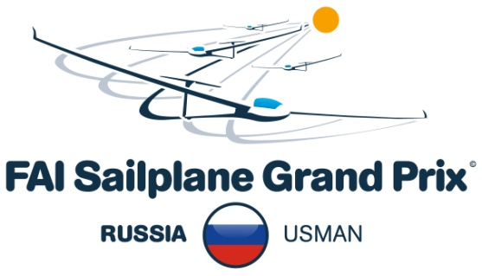
Sailplane Grand Prix Qualification 2016
Usman'
May 1 – May 8 2016

Bulletin No. 1

Location

Airfield: Usman', Russian Federation
ICAO Code: XUOU
Coordinates: N052.01'42" E039.40'06"
Elevation AMSL: 161 m
Runway: Grass, RWY12/30 900x100m
Frequency: 120,650 MHz

Contact

Mobile: +7 903 903 30 04
E-mail: sgp@glidingsport.ru

Time schedule

1. Start оnline registration 01.12.15
2. End online registration 15.02.16
3. Confirmation of pilots in primary entry list 20.02.16
4. Entry fee payment period for primary list pilots 20.02-5.03.16
5. Announcement of places for reserve list pilots 10.03.16
6. Entry fee payment period for reserve list pilots (1 round) 10.03-20.03.16
7. Announcement of places for reserve list pilots (2 round) 20.03.16
8. Entry fee payment period for reserve list pilots (2 round) 20.03-30.03.16
9. Publishing of final list of accepted pilots 30.03.16
10. Announcement of wild card 15.04.16
11. Unofficial Training 25.04-27.04.16
12. Official Training (at least one flying day is compulsory) 28.04-30.04.16
13. Presentation competitors 30.04.16
14. First opening briefing 30.04.16
15. Contest flying 01.05 - 08.05.16
16. Public day TBA
17. Prize Giving Ceremony and dinner 08.05.16 18:00

Competition officials

Competition director: Sergey Ryabchinskiy
Referee: TBA
Task setting: Aleksandr Nitovskyi, Tamara Sviridova
Meteorologist: Ivan Kravchenko
Scorer team: Vladimir Karsakov, Eugeniy Gainulov, Lada Balamut
Website: https://www.facebook.com/SGP2016Russia/
Head of the organizing committee: Sergey Ryabchinskiy

Competition Class

Monoclass: Jantar Std., Jantar Std.2, Jantar Std.3 (without water ballast)

Entries

Registration: The pilot registration form is available on
http://www.sgp.aero/russia2016/event-information/pilot-entry-form.aspx

Number of entries:

The number of entries for the Sailplane Grand Prix Usman' 2016 is limited to a number of 20 pilots. 15 places are allocated for national entries, 5 places are allocated for international entries If at the preliminary closing date there are more international entries than allocated, priority will be given according to the IGC ranking list. The final list of accepted pilots will be published according to the FAI Ranking list valid at 20th of February 2016.
The Organizing Team is going to use one entry as “wild card”.

Glider rent

All competing gliders must be Jantar Std, Jantar Std.2 or Jantar Std.3 only.
The Organizing Team could provide gliders for rent by price 300 euro.
For all foreign competitors gliders will be provided for rent on site by 300 euro for the whole competition period including all official practice days.
Sponsor will pay a half of renting cost for Russian pilots.

Pilot Criteria

- Must be a citizen or resident of the country of one the FAI member NACs, must satisfy the conditions of the FAI Sporting Code, General Section 3.7 on citizenship and representation;
- Must hold a gold badge, or, hold a silver badge or have competed in at least one National Championship;
- Must have flown at least 250 hours as a pilot in command, of which at least 100 hours must be in sailplanes;
- Must hold an FAI Sporting License with a current FAI stamp;
- Must hold a Pilot License or equivalent document issued or endorsed by the authorities of ICAO;
- Must know, understand, and abide by the FAI Rules and the Local Procedures issued for the World Sailplane Grand Prix, by any rulings and requirements stated by the Organizers at any briefings, and the airspace regulations in force during the Championships.

Entry fee

Entry fee will be 100 € for each participating pilot and covers all operational costs, except aero tows.
Bank account details for entry fee will be published later.

Accepted pilots will be asked to transfer Entry fee after 20th of February. Please do not pay Entry fee before 20th of February. The payment will have to be done by 05th March by bank transfer to the mentioned account.

Competition Area and Airspace
The contest area will allow tasks with minimum influence of controlled, restricted, dangerous or prohibited airspace. Available airspace is free of restrictions to the west and east directions with the altitude 0 - 3000m QNH. There could be rare cases with local limitations up to 1500m QNH.

Local Procedures
The local procedures will be published on the competition website.

Aero tows
Aero tow to 700 m AMSL is 15 €.

Contest Numbers
The rules concerning the visibility of contest numbers must be followed (see Sailplane Grand Prix rules). If two contest numbers are identical or possibly easy to confuse (e.g. “India, India” and “one, one”) the competitors which registration occurred later will be required to change his Contest Number.

Flight Documentation
Documentation will be done by GNSS FRs only. All flight recorders, which have received IGC approval for IGC championships before the April 29th, 2016, will be admitted. This applies to both primary and secondary flight recorders. Please note that valid GNSS FR calibration certificate not older than 60 months for primary and secondary GNSS FRs may be required.

Accommodation
Special offers for the competitors will be published at official home page soon.

Insurance requirements
Personal medical insurance is required for all team members, covering accidents and sickness, including any hospital costs and transport back to the team member’s country of residence. Pilots shall ensure that their coverage extends to accidents and injuries sustained in gliding competitions.

Official Home Page

Bulletins and all additional information concerning the event will be available at http://www.sgp.aero/russia2016.aspx. Published information in hard copy will not be provided.

